1 Introduction to *γ*-Ray Astronomy . . . . . . . . . . . . . . . . . . . . . . . . . . 3

# 1.1 Cosmic-ray physics 4 1.2 Acceleration mechanisms 6

1.2.1 Electric field acceleration . . . . . . . . . . . . . . . . . . . . . . . . . . . . . . . . . . . . . . . . . 6

1.2.2 Stochastic acceleration . . . . . . . . . . . . . . . . . . . . . . . . . . . . . . . . . . . . . . . . . . . 8 1.2.3 Diffusive Shock Acceleration . . . . . . . . . . . . . . . . . . . . . . . . . . . . . . . . . . . . . . . 8

# 1.3 Production of *γ*-rays 10

1.3.1 Bremsstrahlung . . . . . . . . . . . . . . . . . . . . . . . . . . . . . . . . . . . . . . . . . . . . . . . . . 12

1.3.2 Inverse Compton scattering . . . . . . . . . . . . . . . . . . . . . . . . . . . . . . . . . . . . . . 12

1.3.3 Synchrotron emission . . . . . . . . . . . . . . . . . . . . . . . . . . . . . . . . . . . . . . . . . . . . 14

1.3.4 Curvature radiation . . . . . . . . . . . . . . . . . . . . . . . . . . . . . . . . . . . . . . . . . . . . . 14

1.3.5 Matter-Antimatter annihilation . . . . . . . . . . . . . . . . . . . . . . . . . . . . . . . . . . . . 15

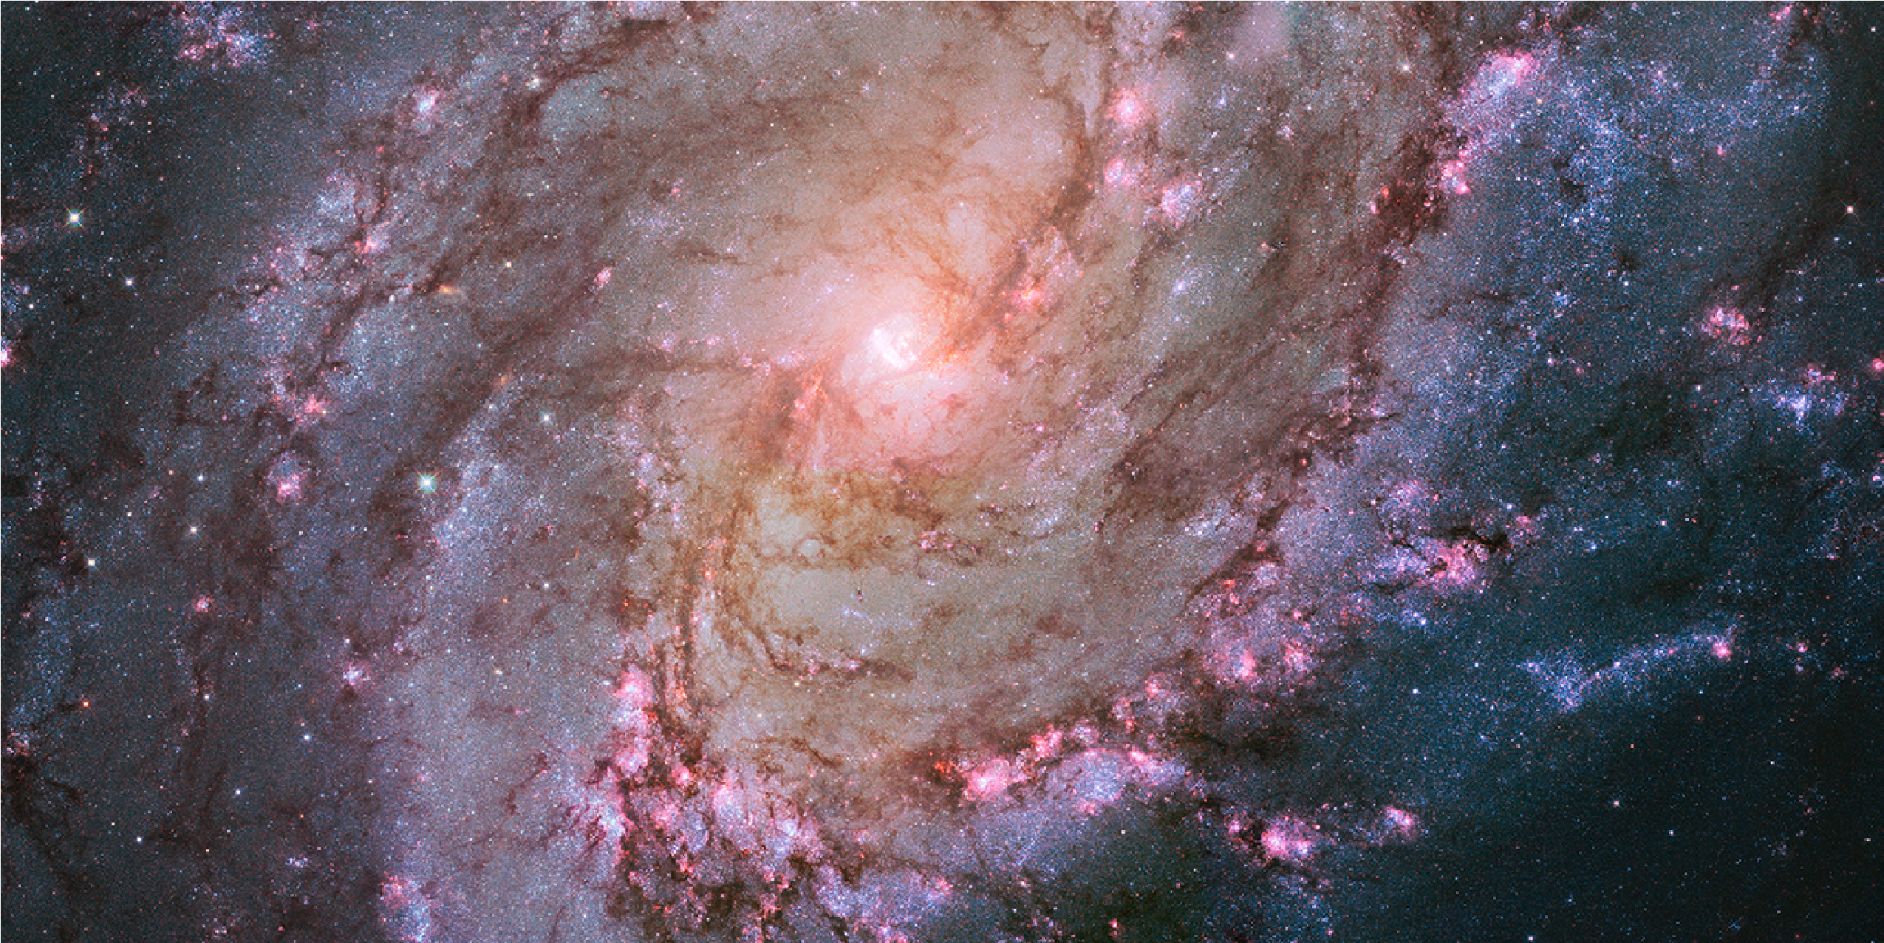

Contents

1.3.6 Hadronic collisions . . . . . . . . . . . . . . . . . . . . . . . . . . . . . . . . . . . . . . . . . . . . . . 15

# 1.4 *γ*-ray Absorption mechanisms 16

1.4.1 Interaction with electrons: Compton effect . . . . . . . . . . . . . . . . . . . . . . . . . 16

1.4.2 Pair production processes . . . . . . . . . . . . . . . . . . . . . . . . . . . . . . . . . . . . . . . . 17

1.4.3 The Extragalactic Background Light . . . . . . . . . . . . . . . . . . . . . . . . . . . . . . . 17

# 1.5 Dark Matter and *γ*-rays: WIMP annihilation 19 1.6 *γ*-ray sources 23

1.6.1 Galactic sources . . . . . . . . . . . . . . . . . . . . . . . . . . . . . . . . . . . . . . . . . . . . . . . . 23

1.6.2 Extragalactic sources . . . . . . . . . . . . . . . . . . . . . . . . . . . . . . . . . . . . . . . . . . . . 31

1.6.3 Potential Dark Matter annihilation emission sources . . . . . . . . . . . . . . . . . . 36

1

2 Detection of *γ*-rays . . . . . . . . . . . . . . . . . . . . . . . . . . . . . . . . . . . . . . . . 41

# 2.1 Space detectors 42

2.1.1 Compton detectors . . . . . . . . . . . . . . . . . . . . . . . . . . . . . . . . . . . . . . . . . . . . . 42

2.1.2 Pair production detectors . . . . . . . . . . . . . . . . . . . . . . . . . . . . . . . . . . . . . . . . 45

# 2.2 Extensive Air Showers 46

2.2.1 Electromagnetic Showers . . . . . . . . . . . . . . . . . . . . . . . . . . . . . . . . . . . . . . . . 48 2.2.2 Hadronic showers . . . . . . . . . . . . . . . . . . . . . . . . . . . . . . . . . . . . . . . . . . . . . . . 50

2.2.3 Electronic showers . . . . . . . . . . . . . . . . . . . . . . . . . . . . . . . . . . . . . . . . . . . . . . 52

# 2.3 Cherenkov radiation 52 2.4 Ground-based detectors 56

2.4.1 Particle detectors . . . . . . . . . . . . . . . . . . . . . . . . . . . . . . . . . . . . . . . . . . . . . . . 56

2.4.2 Atmospheric Cherenkov Telescopes . . . . . . . . . . . . . . . . . . . . . . . . . . . . . . . 57

During many centuries humanity has looked towards the skies and wondered about the mysteries of the universe. At first, with the naked eye, our ancestors measured the movements of astronomical objects and used them as calendars and guidance. Since the invention of the optical telescope by Galileo in 1609 AD we can say modern Astronomy was born. However, we were looking only to a small part of the universe, being only able to study the starts through the visible light they were emitting. Like an incomplete symphony where we can only listen to the melody of one instrument, our knowledge of the physics of the cosmos was incomplete and purely limited to the thermal emission of stars. It wasn’t until the first half of the *XX* century that we could start talking about the *multiwavelength* astronomy with the first infra-red, radio, ultraviolet and X-ray observations. The most energetic part of the electromagnetic spectrum, *γ*-rays, were first detected in the 1960s. The emission of this high energy radiation (above 100 keV) belonged to the *non-thermal* universe, meaning they can not be produced through thermal processes, but other physical phenomena come into play mostly involving interactions of relativistic particles.

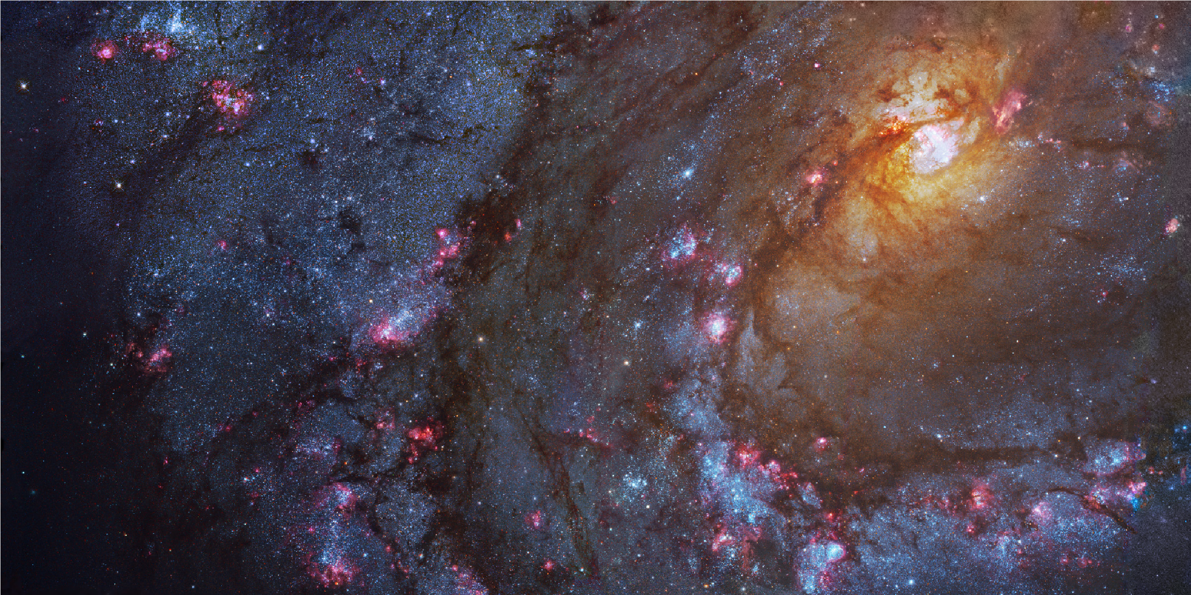

1

. Introduction to

*γ*

-

Ray Astronomy

Along with the multiwavelength astronomy, other messengers from the sky that evidenced the existence of non-thermal processes were discovered: In 1912 the Austrian physicist Victor Hess found that the puzzling source of high levels of ionizing radiation in the atmosphere were actually charged particles coming from space. These particles were later named Cosmic Rays (CRs) by Millikan, and as will be explained later, their origin was thought to be closely related to the origin of *γ*-rays.

The Astroparticle physics field studies this relation, combining astrophysics (*γ*rays) and particle physics (CRs and other cosmic messengers, as neutrinos), to face unresolved problems like the origin and acceleration mechanisms of CR towards the completion of the cosmic symphony that is the Universe.

This chapter will be an overview of the basic concepts of CR and *γ*-ray physics,

3

their production, acceleration and absorption, and their known sources of emission in the universe.

# 1.1 Cosmic-ray physics

CRs are relativistic charged particles arriving to the atmosphere from the outer space. Their origin and the mechanisms that accelerate them to reach such high energies is still unknown. However there are arguments pointing towards that they are accelerated in very violent events in the universe, such as supernova explosions. Several measurements strongly support that galactic CRs are in fact accelerated in Supernova Remnant (SNR) [36], [71], [132].

As they are charged particles, they suffer from the effects of the magnetic fields

(both interstellar and Earth magnetic fields) which divert their trajectories and make very difficult to trace back their original direction. Nevertheless, they can interact with the medium close to their sources producing *γ*-rays through processes such as Inverse Compton (IC) scattering or decay of neutral pions. Observing *γ*-rays which travel in straight lines from their origin can give information on how and where do CRs are produced and interact with the medium.

The composition of CRs arriving to the Earth is mainly protons (86%), alpha particles (11%), other heavy nuclei (1%) and electrons (2%). We can distinguish between two types of cosmic-rays: If they reach the Earth unaltered from their sources, they are known as *primary CRs*, while if they come as the product of inelastic collisions in the Interstellar Medium (ISM), they are called *secondary CRs*.

The spectrum of CRs is shown in figure 1.1. For the most part of the spectrum it can be described as a piecewise Power Law which spectral index *γ* changes along different regions of the spectrum [131]:

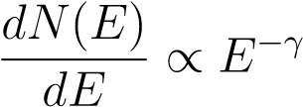 (1.1)

Where N is the differential flux of CRs and E is the energy.

* From few keV to less than 10 GeV, CRs are produced locally in solar flares and coronal mass ejections from the Sun [34], with an spectral index ∼ 5 [115].
* Up to the *knee* (below 106 GeV): CRs follow a simple power law with spectral index *γ* ∼ 2*.*7. In this region CRs are considered to have a galactic origin, accelerated in SNRs.
* From the *knee* to the *second knee* (at 108 GeV) the spectral index becomes ∼

3.1.

* Between the *second knee* (at 108 GeV) and the *ankle* the spectral index is ∼ 3.3.

1.2 Acceleration mechanisms

* Energies above the *ankle* (∼ 109 GeV): CRs coming from extragalactic sources are predominant, with a hardening in the spectrum back to an index ∼ 2.7 . At such high energies, particles are no more confined by galactic magnetic fields so they travel with their trajectories unperturbed, allowing to do estimations of their direction. These kind of very energetic CRs can be produced in Active Galaxy Nuclei (AGN), Gamma Ray Bursts (GRBs), radio galaxy lobes and intra-cluster medium in galaxy clusters.
* At energies above ∼ 4 − 51010 GeV a strong suppression is observed, named the GZK cutoff, which can be interpreted as a theoretical upper limit on the energy carried by CR from distant sources.

As mentioned, from the regions above is possible to differentiate two CR origins: galactic CR and extragalactic CR. Below the *knee*, CRs are produced in galactic accelerators (SNRs) and this energy can be considered a limit on the acceleration that is possible to gain from these kind of objects. CRs with energies above the *ankle* come from extragalactic sources and so, their higher acceleration must come from different phenomena, more violent and energetic (AGN, GRBs, etc.). The transition in the spectrum, although still not well understood, can be explained by the effect of the galactic magnetic field in the trajectories of CRs, and the effect of galactic wind termination shocks as a re-acceleration process [131].

The Larmor radius defines the curved trajectory of charged particles moving perpendicular to a magnetic field. For energies over the *ankle* it starts to become larger than galactic scales, hence extragalactic CRs propagate linearly and unaffected by the galactic magnetic field, while galactic (less energetic) CRs propagate diffusively through the ISM.

The chemical composition of galactic CRs is very similar to that of the Solar System (see figure 1.2), suggesting a similar origin (stellar interiors) but with some discrepancies in certain elements. The most noticeable difference regards Li, Be and B, and to a lesser extent sub iron elements Mn, Cr, V, Ti and Se. The abundances of these elements are small in stars because they are rapidly consumed by nuclear reactions, but they are present in CRs due to *spallation* of carbon and oxygen nuclei [110] and other abundant heavy nuclei as Fe and Ni [130].

# 1.2 Acceleration mechanisms

Acceleration mechanisms take place in astrophysical plasmas which in general consists on thermal plasma components, a magnetic field and non-thermal distributions of fast particles. Within the plasma, turbulence and plasma waves take place, having an important role in particle acceleration. The mechanisms that accelerate CRs to the huge energies observed, that can reach up to 1020 eV are still a topic of debate and research in the high energy astrophysics field. Several particle acceleration mechanisms are proposed to explain the CR spectrum, which should be able to achieve the highest

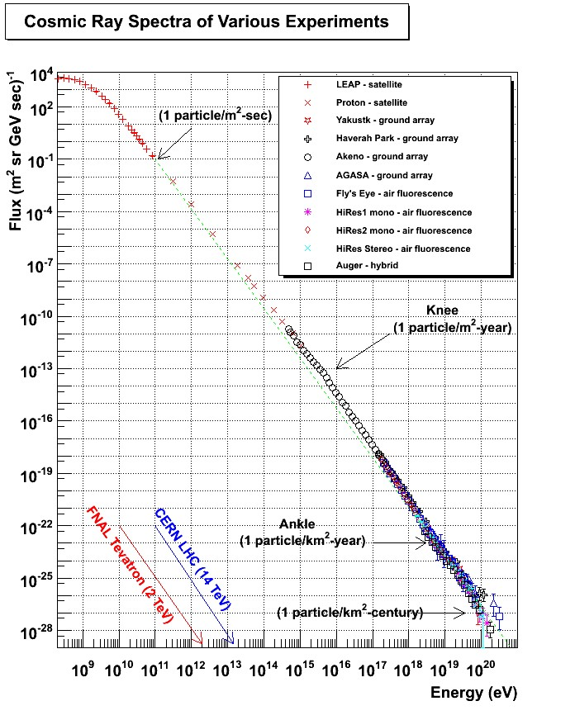

Figure 1.1: Cosmic ray spectrum from [76]. Green line shows the fit to a power law with spectral index 2.7.

1.2 Acceleration mechanisms

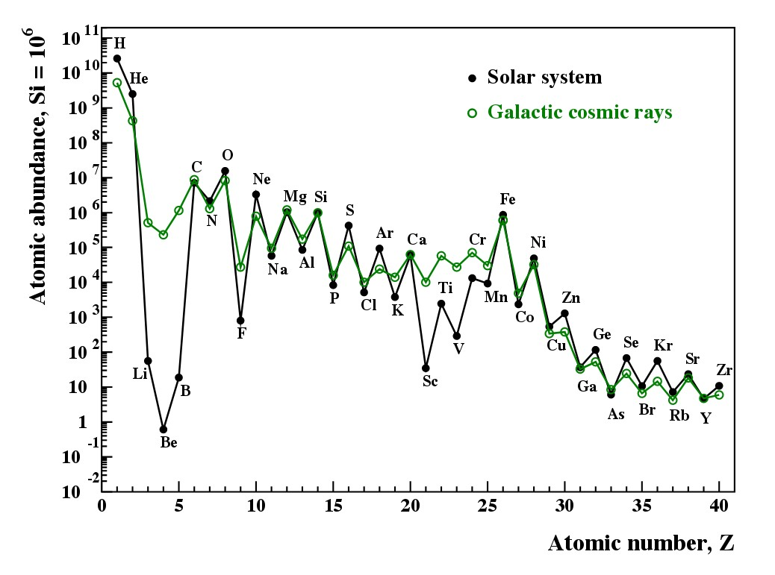

Figure 1.2: Abundances of elements of galactic CRs compared to the Solar Sytem, from [130].

energies measured for CR and reproduce the spectral shape of a power law with an index ∼ 2*.*7, and the abundances of elements measured [82], [111], [100].

## 1.2.1 Electric field acceleration

Electric fields parallel to magnetic fields can accelerate charged particles and can arise during magnetic field reconnection (the breaking and reconnecting of oppositely magnetic field lines in a plasma). Because ideal Magnetohydrodynamics (MHD) of plasmas require the paralell component of electric field to be null *E*k = 0, non-ideal MHD effects are needed to explain the development of *E*k = 0, such as resistivity or inertial effects on Alfvén waves (a type of MHD wave where ions oscillate in response to a restoring force provided by an effective tension on the magnetic field lines).

This kind of acceleration is believed to take place in magnetic reconnection of the

Earth’s magnetotail, accelerating auroral electrons; Also, reconnection in pulsar gaps

(see section 1.6.1) could produce this kind of acceleration which should involve large oscillations in *E*k [100].

## 1.2.2 Stochastic acceleration

Stochastic acceleration, also known as *Second Order Fermi acceleration* or simply *Fermi process*. This idea was developed by Enrico Fermi in 1949 [59] as a mechanism to explain acceleration of galactic CRs. The basic concept is that particles can gain velocity after being reflected several times by randomly moving magnetized clouds

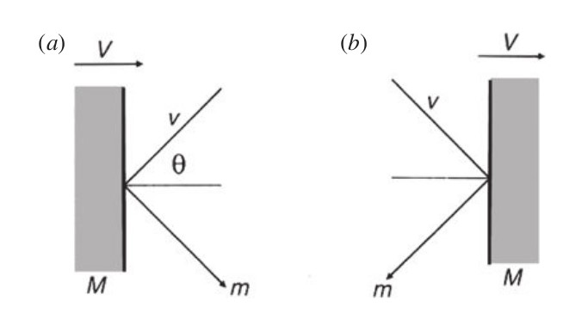

Figure 1.3: Collision of a particle of mass m with velocity v against a cloud of mass M and velocity V, a) head-on, b)head-tail, from [95].

in the ISM. Fermi showed that after a characteristic time *τesc*, the spectrum of the accelerated particles would follow a power law. If the particle is moving with a pitch angle *θ* (the angle between the particle velocity vector and the local magnetic field), the gain in energy after a collision with a cloud moving with velocity *V* will be [95]:

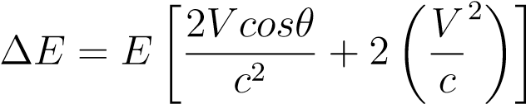 (1.2)

Where E is the energy of the particle before the collision. Between collisions the particle will be moving inside a plasma and will suffer scattering due to hydrodynamic waves, the total gain in energy has to be averaged over a set of random *θ* angles. The probability of a collision is proportional to the relative velocities of the particle (v) and the cloud (*V* ). If *v* ≈ c the probability of a head-on collision *P* ∝ 1 + (*V/c*)*cosθ* is slightly higher than the probability of head-tail collision *P* ∝ 1 − (*V/c*)*cosθ* (see figure 1.3) hence the total, averaged in all *θ* angles between 0 and *π*, gain in energy will be positive:

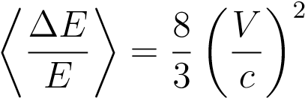 (1.3)

Being the increase in energy *second order* proportional to *V/c*. However this process cannot be the main source of particle acceleration: the velocities of interstellar clouds in the ISM is too low (*V/c* ' 10−4), the mean free path of CRs in the ISM is too high (the number of collisions would be ∼ 1*yr*−1) and the particles should be injected in the acceleration region with already high velocities (*injection problem* which actually is present in every acceleration mechanism).

## 1.2.3 Diffusive Shock Acceleration

The most popular acceleration mechanism in astrophysical plasmas, which is believed to take place in SNRs (the best candidates for galactic CR production) is known as Diffusive Shock Acceleration (DSA) or *First Order Fermi acceleration*. This mechanism revisits the original idea formulated by Fermi of particles colliding with randomly moving "magnetic mirrors" in the ISM, but with all the collisions happening always head-on. For example, when two clouds are approaching each other and the particle bounces back and forth [100]. This process can happen in the presence of strong supersonic shock waves propagating through a diffuse medium, like the ones produced after a Supernova (SN) explosion (see figure 1.4). A flux of relativistic particles is assumed to exist in both sides of the shock, which are moving much faster than the latter. Each time a particle crosses to one side or the other, their velocity becomes isotropic in the frame of reference of the moving fluid. Since on every crossing the particle encounters gas moving towards it at a velocity proportional to the shock velocity (U), which for a fully ionized plasma composed by monoatomic perfect gas is ∼ 3*/*4*U* ([95]) it will receive a boost in energy of the order ∼ *U/c*. That is why this process is called *first order* in counterpart to the classical second order Fermi acceleration where the energy gain in each collision is proportional to ∼ (*U/c*)2. DSA is able to predict a spectral index of ∼ 2, very close to the observed for galactic CR. Also, is the only acceleration mechanism efficient enough to transfer the observed amount of energy in SNR to particles. On the other hand, it exists an upper limit on the maximum energy that a particle can gain through DSA which is set to ∼ 1014 eV [93], so is still not enough to explain the full CR spectrum, which reaches up to ∼ 1020 eV.

# 1.3 Production of *γ*-rays

Although CRs have been known for many decades, it is difficult to make conclusions about their origin and acceleration mechanisms. As they are charged particles, their trajectories are deflected while travelling trough the ISM, hence their incoming direction does not point towards the source of origin. Nevertheless, CRs can interact with the medium producing *γ*-rays through several mechanisms, which reach the Earth undeflected, offering a very interesting fashion to indirectly study CR origin, acceleration and diffusion in the ISM. Γ-rays are the most energetic radiation in the electromagnetic spectrum. The range of energies goes from 100 KeV to hundreds of TeV.

When we talk about radiation production, we can distinguish between two main mechanisms which involve very different physical phenomena: thermal and nonthermal processes. A large fraction of the low energy radiation emitted by stars or interstellar dust is produced by thermal processes following a black body spectrum. To produce radiation as energetic as *γ*-rays a temperature of the order of 1010 K would be needed, which is something that was only reachable in the Big Bang conditions. Therefore to understand the production of *γ*-rays we must study the so called *non-*

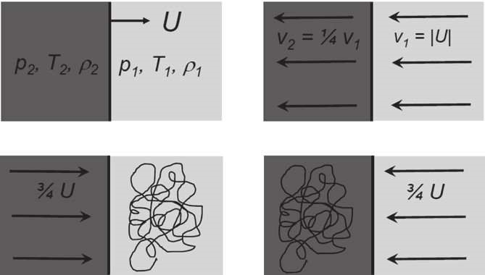

Figure 1.4: Scheme of the *Diffuse shock acceleration* from [95]. *Upper left*. Observer frame: A diffusive shock is propagating at velocity U. *Upper right*. Frame where the shock front is at rest. The velocities of the gas in both sides of the front, assuming is fully ionized, have a ratio of 4. *Lower left*. Frame of reference where the upstream gas is at rest, the distribution of velocities of the high energy particles is isotropic. *Lower right* Same case as previous, but in the reference frame of the downstream gas.

*thermal universe*, where radiation is produced by interactions of relativistic particles moving in electromagnetic fields. In general, *γ*-rays are produced in two kinds of scenarios: leptonic emission (produced mainly by electrons) and hadronic emission (produced mainly by protons). Which one of those is dominant in astrophysical particle accelerators is still a subject of debate and will be commented in section 1.6 about *γ*-ray sources. In this section a brief summary on the different *γ*-ray production mechanisms (see figure 1.5) is given.

## 1.3.1 Bremsstrahlung

From the German ’braking radiation’, the bremsstrahlung process occurs when a charged particle is decelerated by the electric field produced by an atomic nucleus. While their trajectory is deflected, the particle emits electromagnetic radiation with amplitude proportional to the magnitude of the deceleration suffered. The differential cross section for a particle of charge *e*, mass *m*, carrying an energy *Ee* to radiate a photon between energies *Eγ* and *Eγ* + *dE* when interacting with the Coulomb field is:

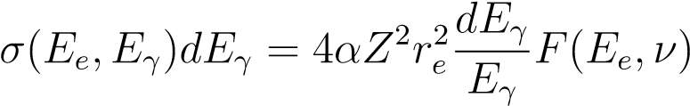 (1.4)

Where:

 (1.5)

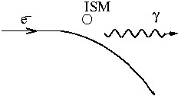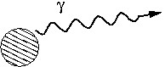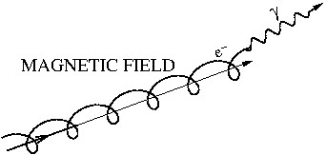

(a) Bremsstrahlung (b) Thermal Bremsstrahlung (c) Synchrotron emission

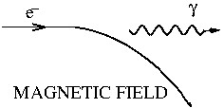

(

d) Curvature radiation

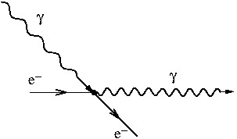

(

e) Inverse Compton scatter

-

ing

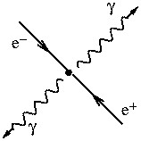

(f) Electron-positron annihilation

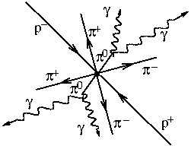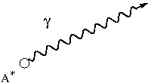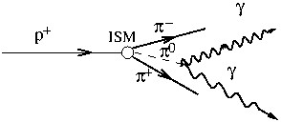

(

i) Hadronic collision

(h) Radioactive emission

(g) Proton-antiproton annihilation

Figure 1.5: Diagrams of the different *γ*-ray production processes. Figures extracted from [109] .

Being *α* the fine structure constant and *ν* = *Eγ/Ee* the fractional energy carried by the photon [117]. From equations 1.4 and 1.5 can be seen that the acceleration suffered by the particle is ∝ *Ze*2*/m* , then while any charged particle can suffer bremsstrahlung, it is going to be much more efficient for electrons than for protons which have a higher mass. The photons emitted will have a continuum spectrum with energies of the same order of the particle, which for cosmic electrons in a gas is going to be a power law [139]. Bremsstrahlung is mainly efficient under high-density conditions. It takes place in gaseous nebulae that contain ionized gas, such as SNR, and in the intracluster medium of galaxy clusters [98].

## 1.3.2 Inverse Compton scattering

IC scattering is the inelastic interaction where a relativistic charged particle transfer a considerable amount of energy to a photon. In the frame of reference of the electron the photon will suffer an "energy boosting" [139]. The energy of the scattered particle is *E* = Γ*mc*2, where Γ is the Lorentz factor, and we can define the parameter *α* = *hν/mc*2, where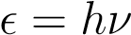 is the initial energy of the photon. We can differentiate between two regimes depending on the initial energy of the photon:

* *Thomson regime*: For low values of *α*, particle recoil can be neglected and the energy of the photon after the scattering follows:

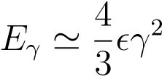 (1.6)

* *Klein-Nishina regime*: For large values of *α*, particle recoil is significant and in this case the energy of the photon after the interaction is:

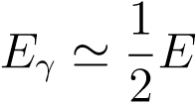 (1.7)

Photons from the Cosmic Microwave Background (CMB) are typical targets for IC scattering, together with synchrotron photons or photons thermally emitted by astrophysical sources. This mechanism is predominant in Very High Energy (VHE) *γ*-ray emitters, like in the jets of AGN and TeV blazars. The spectrum of the photons boosted by this process will follow a power law related to that of the population of relativistic electrons in the medium (∝ *Ee*−Γ*e* ):

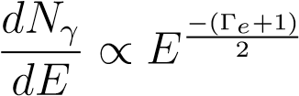 (1.8)

## 1.3.3 Synchrotron emission

Synchrotron emission is produced when a charged particle is moving in a magnetic field. The particle will follow an spiral path, with constant velocity along the field lines, while being accelerated towards the center of its orbit. The particle will suffer energy losses that for relativistic particles follow a continuum spectrum [139] with a critical frequency *wc* at which the maximum power is emitted:

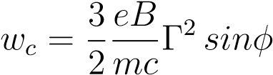 (1.9)

Where *e* and *m* are the charge and mass of the particle, *B* is the magnetic field, Γ is the Lorentz factor and *φ* kis the pitch angle bewteen the direction of the magnetic field and the particle. The total energy loss is given by

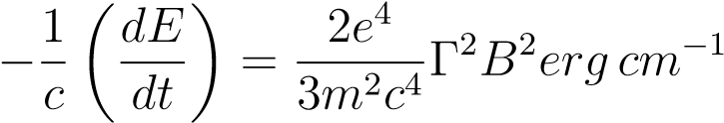 (1.10)

Following 1.10 the power emitted is inversely proportional to the mass of the particle so it will be comparatively much more efficient for electrons than for protons.

Synchrotron radiation of ultra-relativistic particles is the most important contribution to the non-thermal universe (radio, X-rays...). According to 1.9 the production of High Energy (HE) *γ* − *rays* will require too high values of B and *Ee*, but regions emitting synchrotron radiation contain relativistic electrons capable of IC scattering [77], which will acquire much higher energies.

## 1.3.4 Curvature radiation

In presence of very strong magnetic fields, of the order of 1011-1013 G, electron and positrons will be forced to follow a trajectory parallel to the magnetic field lines. Since the lines are curved, with a curvature radius *ρc*, the particle will emit *curvature radiation* in the direction of movement, with a characteristic photon energy [122]:

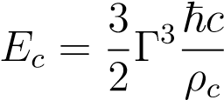 (1.11)

Typical environment where curvature radiation takes place are the surroundings of pulsars, due to the extremely high magnetic fields close to their surfaces. An electron with an energy of 10 TeV moving along a field line with a curvature of 108 cm, which is typical for pulsars, emits photons of energy ≈ 2*.*5 GeV [117].

## 1.3.5 Matter-Antimatter annihilation

Matter-antimatter pair annihilation processes can produce *γ*-rays. The most common case is electron-positron annihilation (*e*−*e*+ → 2*γ*). If the two particles are at rest, they produce *γ*-rays with energy equal to their masses (0.511 MeV). If the particles are thermalized but with low energies, such as the electrons of the ambient gas/plasma, they form the unstable state called positronium which can annihilate into 3 photons forming a continuum [24]. For relativistic particles interacting in-flight, the annihilation cross section is:

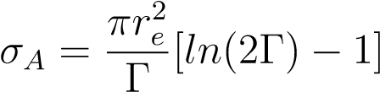 (1.12)

Where Γ = *Ee/mec*2 is the Lorentz factor of the positrons and *re* = *e*2*/mec*2 =

2*.*82 × 10−13cm is the classical radius of the electron. The result of the interaction is the emission of two photons with a continuum of energies. At very high energies, the cross section of equation 1.12 is quite low, leading to very high mean free paths and long lifetimes for the positrons, which typically will be affected by other processes before annihilating. Positrons can lose energy gradually without escaping the galaxy until the cross section is high enough and they annihilate [117].

Proton-antiproton annihilation can also produce *γ*-rays indirectly by the production of neutral pions *π*0 which decay into *γ*-rays later on [127]. In theory, antiprotons can be produced by interactions of protons with matter, but this process is much less efficient than the direct production of *π*0 mesons [139] so the production of *γ*-rays this way is considered marginal.

## 1.3.6 Hadronic collisions

While most of the processes described above were dominated by electron interactions

(leptonic scenario), we now focus on the processes that constitute the hadronic contribution to the production of *γ*-rays, which are believed to be the dominant *γ*-ray production processes in SNRs and AGN.

Protons accelerated to relativistic energies in extreme environments, such as strong magnetic fields or jets can collide with other hadrons producing mesons, kaons and hyperions. The most common interaction is the proton-proton collision to produce pions (*π* mesons):

*pp* → *ppπ*0 (1.13)

With a threshold energy of the proton, which is the minimum kinetic energy the pair of protons must have in the collision to produce the meson:

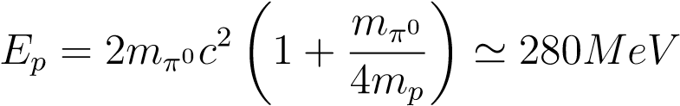 (1.14)

Where *mπ*0= 134.97 MeV is the mass of the *π*0-meson and *mp*=938.27 MeV is the mass of the proton [24].

Neutral pions *π*0 decay into *γ*-rays within a short lifetime *τ* = 8*.*6 · 10−17s through the channels:

*π*0 → *γγ* (98*.*8%) (1.15)

*π*0 → *e*−*e*+*γ* (1*.*2%) (1.16)

Then the energy of the photons emitted by the *π*0 peaks at *Eγ* = *mπ*0*c*2*/*2 '= 67*.*5 MeV, but in the laboratory frame of reference this energy depends on the energy of the *π*0 and the angle of the proton trajectory with respect to the *π*0 allowing the emitted *γ*-rays to reach very high energies.

The collision of protons can also produce charged mesons, which can decay into neutrinos *νe,µ* with an spectrum similar to that of the photons [24]. Finding a correlation between *gamma*-ray emission and astrophysical neutrinos from a certain source would be an unequivocal way to differentiate between leptonic and hadronic emission. Their spectrum shape and the lack of correlation with X-rays could be other ways to distinguish hadronic and leptonic emission.

1.4 *γ*-ray Absorption mechanisms

# 1.4 *γ*-ray Absorption mechanisms

Because *γ*-rays are very energetic, they can travel long distances without being altered. However there are mechanisms that can produce losses of energy of astrophysical *γ*-rays or their total absorption, altering the spectrum of that is detected from Earth. These mechanisms can be divided in *γ*-matter interactions and *γ* − *γ* processes.

## 1.4.1 Interaction with electrons: Compton effect

Compton effect is produced when a photon is scattered by an electron, shifting the wavelength of the photon to lower energies. The shift in the wavelength goes like:

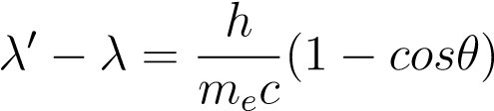 (1.17)

Where *λ*0 is the wavelength of the scattered photon, *λ* the wavelength of the incident photon and *θ* is the scattering angle. In the standard ISM density of 1 atom cm−3, for distances of ∼ 10 kpc, the mean free path for photons of 1 MeV would be of 2 Mpc, thus the Compton effect is negligible. In hot dense plasmas however, were densities are much higher, the effect can be quite important [117].

This effect is used in Compton *γ*-ray telescopes such as described in section 2.1.1.

## 1.4.2 Pair production processes

Pair production is the opposite process to pair annihilation, where two photons interact to produce a pair *e*−*e*+. This is the most common absorption mechanism for HE and

VHE photons. A *γ*-ray with energy 1 which collides with a target photon with energy 2 will produce a pair of particles of mass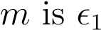 is greater than a threshold energy:

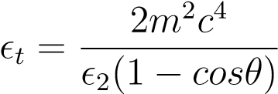 (1.18)

where *θ* is the angle between the trajectories of the photons. In astrophysics, this process occurs when energetic photons traveling through the Universe encounter a radiation field, such as the CMB (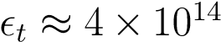eV) or the light of stars (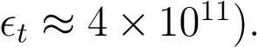

Even though photon-photon collisions are not generally frequent, because the spatial density of the target photons is not very large (≈ 400 cm−3 for the CMB radiation n and ≈ 5 × 10−3cm−3 for extragalactic starlight) the attenuation effect can be appreciated, specially for VHE photons coming from high redshifts. This process also occurs when *γ*-rays penetrate the atmosphere and are absorbed, leading to the production of Extensive Air Showers (EAS), which are the key for ground based *γ*-ray detectors and will be explained in section 2.2.

## 1.4.3 The Extragalactic Background Light

The Extragalactic Background Light (EBL) is the accumulated radiation in the universe due to star formation processes and the emission from AGNs. It is a

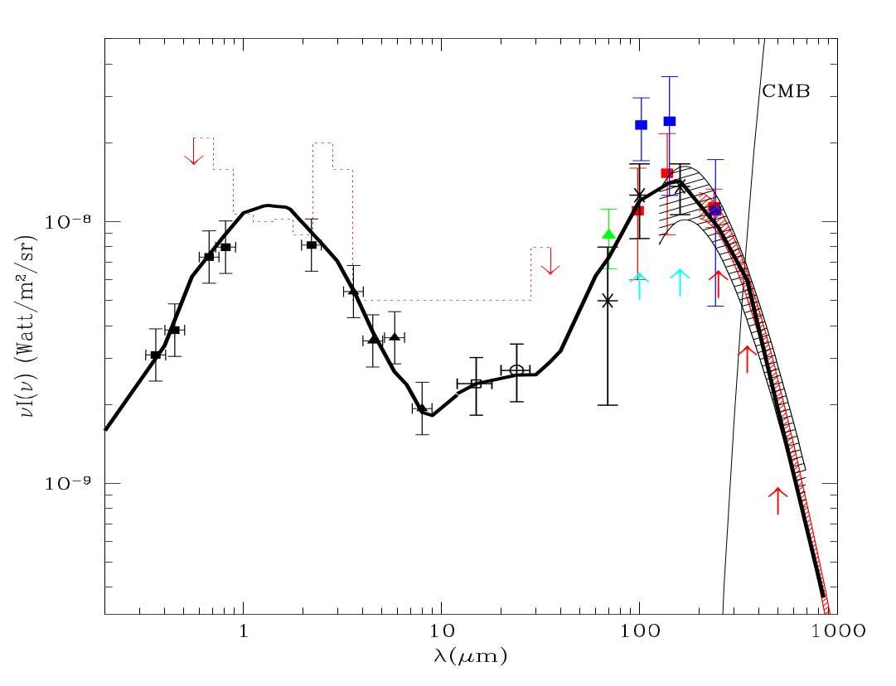

Figure 1.6: Best fit model prediction of the EBL energy density from [61] (thick black line).

fundamental constituent of the universe that permeates it uniformly. The direct measurement of the EBL are very difficult task, mainly because of the foreground light from the Solar System. Phenomenological approaches try to predict an EBL model based on galaxy formation and evolution during the history of the universe and several direct measurements have been done from the far infrared to the optical to set constrains on the density and spectrum of the EBL [56]. Besides the different proposed models, it is accepted that the energy density is characterized by two peaks, as seen in figure 1.6. The first peak, found at ∼ 1*µ*m is the stellar component and the second peak at ∼ 100*µ*m is the dust component, the light re-emitted by cosmic dust.

EBL photons are a typical target for *γ*-rays to produce pair production. The attenuation to the spectrum of a *γ*-ray source at the energy *E* follows the form:

*F* = *F*0(*E*)*eτ*(*E,z*) (1.19)

Where *F* is the observed flux and *F*0 the intrinsic spectrum of the *γ*-ray source, *τ* is the optical depth which depends on the energy and the redshift *z* (as shown in figure 1.7). As a consequence of this dependence, for each energy there is a distance (redshift) at which the universe is optically thick to *γ*-rays, when the optical depth is equal to 1. The spectrum of the *γ*-ray source will suffer a cutoff at the energy that reaches the threshold optical depth, which decreases rapidly with redshift. Observations of this effect in distant sources in the VHE range is very useful to characterize the EBL in

1.5 Dark Matter and *γ*-rays: WIMP annihilation

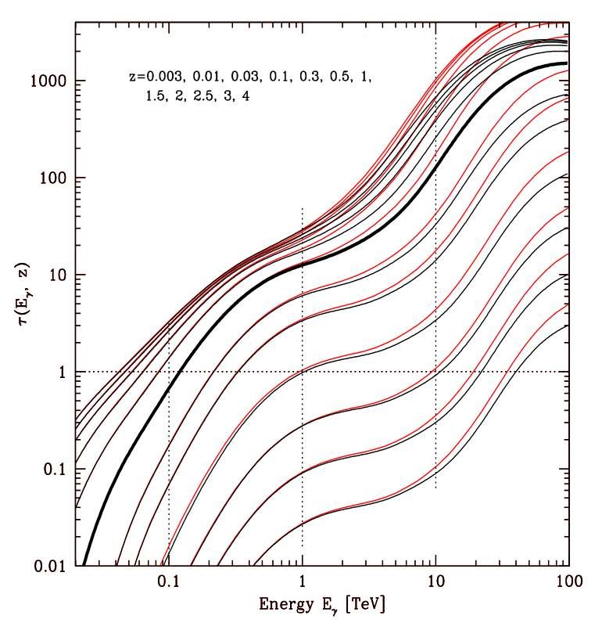

Figure 1.7: Optical depth due to photon-photon collision as a function of energy for different redshift values, from [61].

an indirect way, comparing the expected spectrum to the measured one [102].

# 1.5 Dark Matter and *γ*-rays: WIMP annihilation

The nature of Dark Matter (DM) is one of the most important open questions in modern physics. There are many probes that suggest that the universe is composed of something more than the visible matter: From the Fritz Zwicky measurements on the velocity dispersion in the Coma galaxy cluster [30] and the rotation curves of high-luminosity spiral galaxies obtained by Vera Rubin [121], to the much more modern measurements of the CMB by Planck [114], all of them point to the existence of a non-baryonic type of matter which only interacts gravitationally with Standard Model (SM) particles. Cosmological simulations and cosmological probes such as

Wilkinson Microwave Anisotropy Probe (WMAP) point to a hierarchical structure formation of the universe, where small structures formed first and then merged to the larger. To accomplish for that model, if DM is formed by particles, they should be non-relativistic (Cold dark matter) which decoupled from the thermal equilibrium in the early universe. Hot dark matter models, where DM particles would be still largely relativistic (like neutrinos), would lead to large structures forming first and fragment out later [107].

With these assumptions, we can derive the number density evolution of DM particles today. In the early universe, DM and SM particles were in thermal equilibrium with the photon bath emitted in the Big Bang, and reactions of annihilation and formation of particles were taking place at the same rate. While the universe expanded, these reactions started to be slower than the rate of expansion, so these particles *decoupled* from the thermal bath. This is the moment of *freeze-out*, before that particles had an equilibrium number density *Yeq*, which evolves with time while the universe keep expanding. For DM and using the Boltzmann equation, the number density evolution *dY/dx* follow the equation:

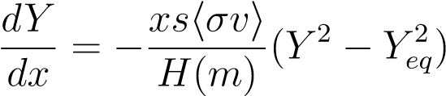 (1.20)

Where m is the mass of the DM particle, x is the scaled time variable *x* = *m/T* being T the temperature of the photon bath at the moment of freeze out, s is the total entropy density of the universe, Y is actually defined as the number density of DM rescaled to s (*Y* = *n/s*) to account for the expansion of the universe, h*σv*i is the velocity averaged cross section for the reaction of DM particles annihilating into SM particles and H(m) is the Hubble rate (which defines the rate of expansion of the Universe) defined as *H*(*x*) = *H*(*m*)*/x*2.

While the annihilation rate of the particles is higher than the expansion rate of the universe (), the number density *Y* remains close to *Yeq*. After the moment of freeze-out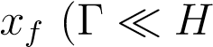), the number density will remain almost constant as shown in figure 1.8.

Following the approach of [94], after freeze-out, the evolution of DM abundance can be written as:

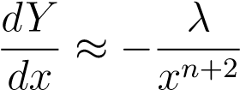, where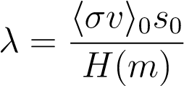 (1.21)

To define *λ* the dependency of the cross section and entropy with *x* was pulled out through the change of variables: h*σv*i = h*σv*i0*x*−*n* and *s* = *s*0*x*−3, where n is an exponent which depends on details of the particle physics model. Taking n=0, the DM abundance today would be ' *xf/λ*. There is no SM particle which can explain the cosmic density of DM measured today Ω*χ*, but if we consider a weak interacting particle in the weak mass regime (*mχ* ∼ 100 GeV), the correct DM density measured by Planck and WMAP arises naturally:



1.5 Dark Matter and *γ*-rays: WIMP annihilation

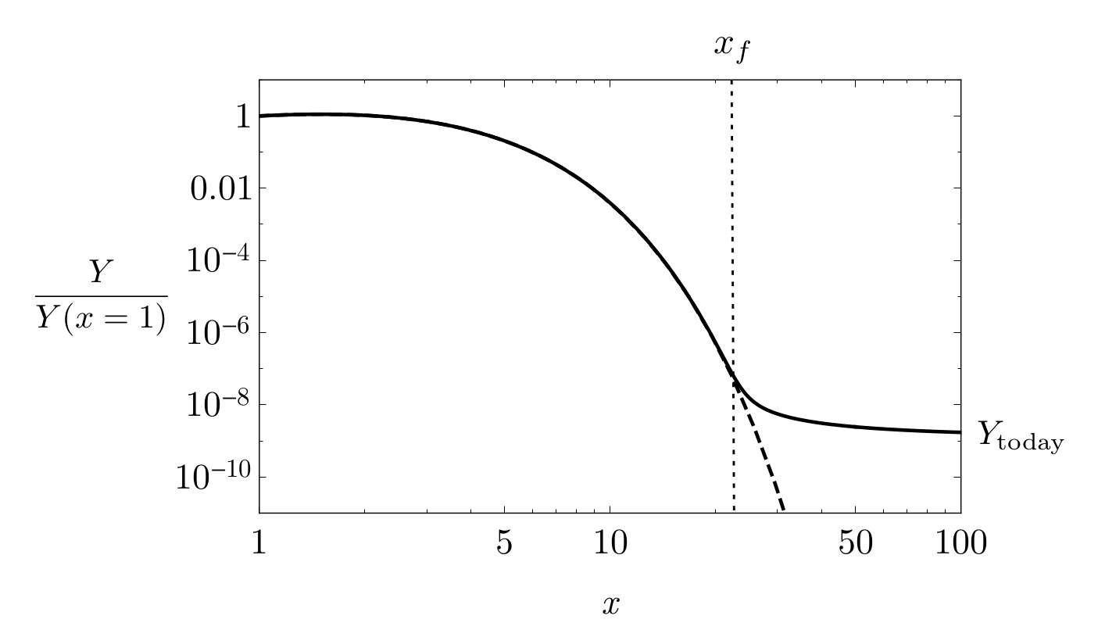

Figure 1.8: Evolution of Cold Dark Matter number density with time variable *x*, *xf* is the time of *freeze-out*, from [94].

where *ρcr* is the critical density in the universe required for it to be at balance. This is called the "WIMP miracle" for the theoretical Weak Interacting Massive Particles (WIMPs) which have some candidates within the Super Symmetry (SUSY) theory. Although the annihilation of these particles would be strongly suppressed after freeze-out, it can still occur in regions with high DM density. The products of this annihilation are pairs of SM particles that can be detected as an excess signal in particle detectors, giving an indirect evidence of the presence of DM.

Γ-ray astrophysics contribute this way to the indirect detection of DM signatures: Two DM particles can annihilate directly into a pair of *γ*-rays with a characteristic line spectrum with *Eγ* = *mχ* or they can annihilate into pairs of other SM particles which afterwards decay giving out a continuum spectrum of *γ*-rays.

The differential flux of photons produced by DM annihilation is described as:

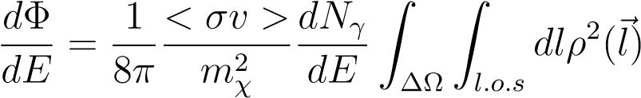 (1.23)

Where *dN/dE* is the spectrum of *γ*-rays from annihilation of a pair of dark matter particles, h*σv*i is the thermal velocity averaged annihilation cross section, *mχ* is the DM particle mass and *ρ* is the dark matter density profile. If DM particle is not its own antiparticle, equation 1.23 should be multiplied by a factor 1/2.

The first term of the equation comes from the already discussed particle physics, depends on the annihilation channel and the mass of the particle. The integral second term is known as the J-factor and is the integral over the line of sight and solid angle ∆Ω of the squared DM density profile (*ρ*) and it is dependent on the source. The most simple density profile for a dark matter halo that we can think of is a self-gravitating isothermal gas sphere, where:

*ρ*(*r*) ∝ 1*/r*2 (1.24)

However, to address the actual physics of galaxies evolution, we need to relay on structure formation simulations which follow the initial DM density perturbations until the formation of current halos. From these simulations and from actual observations [90] we know that the DM density profile can be well reproduced as a six-parameters function of distance *r* from the center of the profile [79][144][90]:

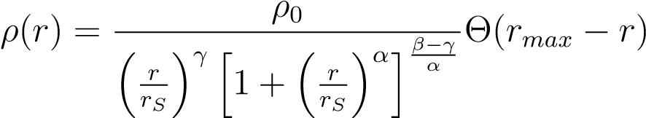 (1.25)

Where Θ is the Heaviside step function, *rS* is the scale radius and *ρ*0 is the characteristic density. These two last parameters depend on the specific DM halo. Setting (*α,β,γ*) = (1*,*3*,*1) we retrieve the Navarro-Frenk-White profile [104]. Combinations of these parameters can be used to fit a possible DM signal to a specific profile. Other types of profiles have also been treated in the literature, such as the Einasto profile

[58].

From 1.23, we can see that the best objects to search for a *γ*-ray signal will be those that are nearby and DM dense, so the J-factor would be sufficiently large relative to the background of *γ*-rays produced by ordinary matter interactions.

# 1.6 *γ*-ray sources

In the previous section, the processes that produce *γ*-ray emission were introduced. In this section, the astrophysical objects where they take place are described. Two major classes of *γ*-ray emitters can be distinguished: galactic sources and extragalactic sources. At the end of the section, potential sources for DM annihilation signals will be also covered. Figure 1.9 show the current known population of VHE *γ*-ray sources based on the observations of the current generation of *γ*-ray detectors, either in space (*Fermi*-LAT) or ground based (the Major Atmospheric Gamma Imaging Cherenkov Telescopes (MAGIC), the High Energy Stereoscopic System (H.E.S.S.), the Very Energetic Radiation Imaging Telescope Array System (VERITAS) and the High-Altitude Water Cherenkov Observatory (HAWC)).

## 1.6.1 Galactic sources

As shown in figure 1.9, the richest region in *γ*-ray sources is the galactic plane, meaning that the majority of detected emitters belong to our galaxy. In this section, the different characteristics of these sources will be described.

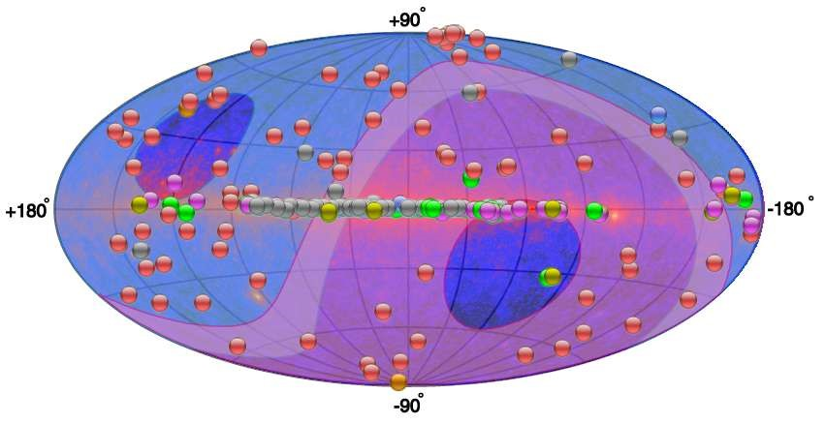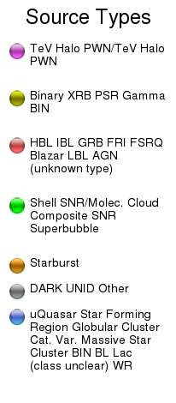

Figure 1.9: Full skymap from TeVCat[138] catalog as of July 2019, with all the detected TeV sources. In the background, the *Fermi*-LAT skymap is shown and the shadowed regions correspond to the MAGIC field of view (blue) and H.E.S.S. (pink).

Pulsars

Pulsars are the most common type of *γ*-ray emitters known. When a massive star

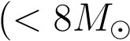) suffers gravitational core collapse at the end of its life, the resulting object is a compact neutron star sustained by degeneracy pressure, where neutronization (the combination of protons and electrons) has taken place due to the extremely high pressures which lead to high densities (*>* 109*g/cm*3). The neutron star comprises 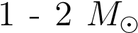 in a radius of 10 - 14 km and as the momentum of the parent rotating star is conserved, the much more compact neutron star will spin at extremely high velocities with periods that can go from milliseconds to a few seconds. This fast spin produces strong magnetic fields in their surroundings where electrons and positrons are accelerated by the electric field aligned with the magnetic field. When the magnetic fields are aligned with the line of sight from the Earth, we can detect a pulsed emission (mainly synchrotron and curvature radiation) with a period as of the rotation of the neutron star, and it is called pulsar. The pulsed emission has been detected in many wavelengths, either radio, optical, X-ray and also in *γ*-rays.

It is generally accepted that the origin of the *γ*-ray emission from pulsars is due to curvature radiation, produced when relativistic electrons accelerated in gaps of the electromagnetic fields powered by the pulsar rotation, get trapped along the lines of the magnetic field [29]. However, the location of the gaps and the acceleration mechanism which dominates is not well known and there are different models proposed (see figure 1.10).

Combined observations of the Crab pulsar from the Imaging Compton Telescope (COMPTEL), the Energetic Gamma Ray Experiment Telescope (EGRET) [92], MAGIC [29], VERITAS [99] and *Fermi*-LAT [5] have shown that their power law

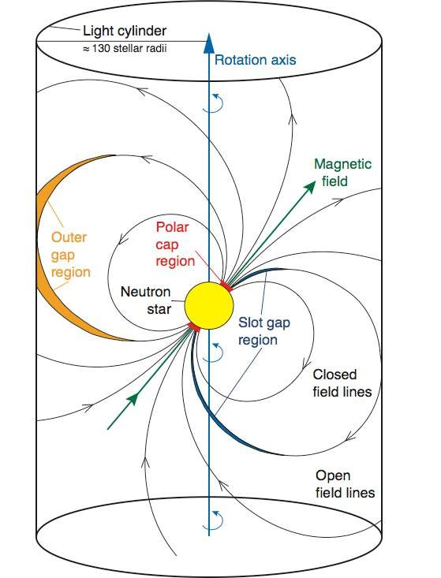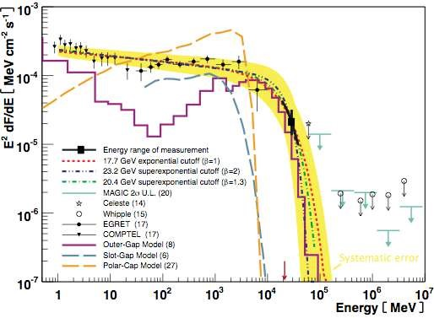

Figure 1.10: *Left:* Crab pulsar’s magnetosphere where the location of the three models (Polar-Cap in red, Slot-Gap in blue and Outer-Gap in yellow) is shown. *Right*: Crab pulsar spectral cutoff. Figures from [29]

spectrum presents a cutoff at energies over a few GeV (see figure 1.10). The detection of the pulsar emission at energies over 25 GeV by MAGIC ruled out the possibility of acceleration happening too close to the pulsar (as the Polar-Cap model assets) because the magnetic pair-production attenuation would provide a super-exponential cutoff at much lower energies to those observed. Current predictions of the Outer-Gap model best explains the observed Crab pulsar spectrum up to date [83]. While pulsars are the most common *γ*-ray emitters, only two have been detected in the VHE range, up to TeV energies: the Crab and Vela pulsars [66].

Supernova Remnants

Supernovae are the result of the evolution of a star, which suddenly becomes much brighter while shells of gas are expelled off back to the interstellar medium in an explosive event. They can be classified in different types by features in their spectrum which also implies a different origin of the explosion. Type II supernovae show hydrogen emission lines, meaning they come from very massive stars ( with hydrogen in their outer layers. After burning lighter elements (H, He, etc.) into heavy nuclei, fusion reactions become inefficient and the imbalance between gravitational forces and pressure radiation lead to the collapse of the central core into a neutron star or a black hole in a violent reaction, expelling shells of material at high velocities. Type I supernovae do not present hydrogen lines, meaning they come from an hydrogen-poor star. They usually are produced by white dwarfs in binary systems which acrete material until reaching the Chandrasekhar limit [41] and suffer a thermonuclear explosion. Type Ia have of Si lines in their spectra. Those type I without Si lines are classified as Ib if they have He lines and Ic if they do not [108]. The structure of ejected material which is left in the surroundings of the parent star is the SNR. They can be classified in different types depending on their spectrum, but the most important feature to differentiate them is the presence (or not) of a shell. There are shell-type SNR, in which the material in the surroundings is heated by the power of the shockwave during the SN explosion. The named *plerion* SNR or Pulsar Wind Nebula (PWN) do not present a shell. The result of the SN explosion is always a central pulsar and their emission is produced by the interaction between electrons ejected to the medium by the pulsar and its huge magnetic field. There is also a composite type of SNR where a plerion is surrounded by a shell and depending on the wavelength observed, they emit more like one type or the other [140]. Depending on the SNR type, the particle acceleration and *γ*-ray emission would have a different origin and features.

* Shell-type remnants: Shell-type remnants, the commonly referred simply as SNRs, are the most popular candidates for CR acceleration. CRs are deflected by magnetic fields in the ISM which makes it impossible to trace back the emission direction, but neutral particles, like neutrinos and *γ*-rays coming from SNRs can be used as tracers of CR acceleration. We know CRs can produce *γ*-rays via hadronic interactions with the gas and dust in the medium. For example, the production of pions and posterior pion decay would give an spectrum with a characteristic peak at 67.5 MeV, if pions are at rest.

As a rough estimation, if we assume that the typical total kinetic energy produced by a SN explosion is around *ESN* ∼ 1051 erg, with a SN rate in the galaxy of about one in 50-100 years, and a constant fraction *η* of the kinetic energy is transferred to hadrons, it can be shown that this fraction has to be of the order of the 10% to retrieve the approximated CR luminosity in the galaxy *LCR* ∼ 2 × 1041 erg/s.

*LCR* = *η* · *ESN* · *SNrate* = 0*.*1 · 1051*erg* · 50*yr*−1 ∝ 1041*erg/s* (1.26)

A more detailed analysis using real data of galactic SNR was done by [35] arriving at the conclusion that future *γ*-ray data can be used to constrain the amount of CR energy coming from SNR. However, there are still problems on proving this hypothesis because many of the *γ*-ray signatures coming from SNR have a leptonic origin rather than hadronic. Also, for SNR to reproduce the full spectrum of CR, SNRs should be pevatrons (meaning they can accelerate CR to PeV energies) at some fraction of their lifetimes, to reach the region after the *knee*. Still, no SNR pevatron has been observed yet but high hopes are deposited in the next generation of *γ*-ray experiments [49].

* Plerions or Pulsar Wind Nebulae. As mentioned, PWN are powered by a central rotating pulsar which dissipates kinetic energy over time in the form of *spin down luminosity*. This energy is injected steadily into the surrounding nebula of ejected material that was formed during stellar evolution. To understand the features of the emission of Pulsar Wind Nebulae (PWNe), it is important to follow their evolution with time and how the period, spin down luminosity and magnetic field changes [64]. A pulsar is formed in a SN explosion and the final state of the pulsar and its PWN will depend on how it interacts with the SNR. If the SNR expands outward freely, the pulsar will remain in the center, but if a reverse shock happens, reverberations between the PWN and the shock can produce instabilities which in the end will displace the pulsar from its original position, even being able to cross away the SNR shell.

Strong magnetic fields in pulsars create currents of particles of the surrounding nebula, producing pulsar winds. Electrons accelerated this way produce synchrotron radiation from radio to X-ray wavelengths. The wind starts decelerating when reaching the nebula radius, due to the more slowly expanding material and thus a wind termination shock is formed. The TeV *γ*-ray emission from PWNe is explained as IC emission produced by the relativistic particles in the shocked wind interacting with the synchrotron photons. The Crab PWNe was the first source detected of this type, associated with a SN explosion observed in 1054CE, and has become a sort of standard candle for *γ*-ray astrophysics.

* Composite remnants. A rare type of SNR is a combination of the previous two, where a PWN is surrounded by a shell-type SNR. Usually, PWN are considered young SNRs while shell-types are older systems. Composite SNRs could be an intermediate phase of evolution where the shell and the PWN evolve and interact together [72]. In these systems, the PWN formed in the interior of the SNR expands outwards and it can encounter the inward reverse shock of the SNR [80]. Some examples of this kind are SNRs W28, W44 and SNR G21.5-0.9, which is shown in figure 1.11.

*γ*-ray binaries

*γ*-ray binaries are systems composed by two objects orbiting each other: One is a compact object, such as a pulsar and the other can be an ordinary massive star big enough to reach the Roche lobe of the pulsar and so stellar winds connect the two objects. Just a few objects (∼ 10) of this kind have been detected in VHE *γ*-rays very recently, and yet the exact mechanisms of the origin of their emission are unknown. There are two main explanations to the HE and VHE emission in *γ*-ray binaries. It can be produced by accretion energy released in the form of relativistic jets, or on the other hand, by the energy emitted by the pulsar in the form of pulsar winds in a similar way as in PWNe. The first case is denominated the *microquasar* scenario due to its similarities with AGN (also known as quasars) but emitting jets in a smaller scale. However, a variety of indirect evidences seem to favour the pulsar wind interpretation mainly based in the spectral similarities of the known binaries with the power of a pulsar spindown. Also the presence of strong magnetic fields and morphological

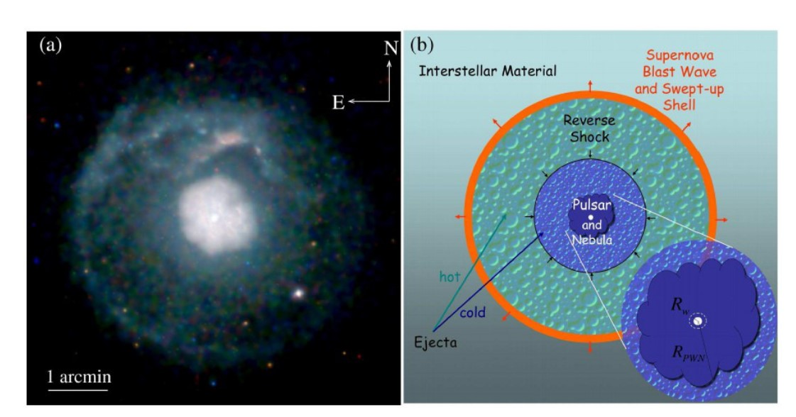

Figure 1.11: a): Chandra X-ray image of the composite SNR G21.5-0.9. b): Diagram of a PWN inside a SNR. Pictures from [80].

characteristics of radio emission are similar features to those found in PWNe [57].

Novae

Binary star systems are rather common objects in the universe. One of the stars can be more massive than the other, evolving faster and becoming a white dwarf while the second star can still be in its main sequence phase. If this happens, the white dwarf can start to attract material from the companion, building an accretion disk. The hydrogen rich gas in the surface of the white dwarf starts heating in the bottom layers and become electron-degenerate, leading to a chain of thermonuclear explosions [45]. This event is known as "classical nova". When the companion star is a red giant, which has highly increased its volume, the system is called a *symbiotic binary system*. In this case, the interaction between the stellar wind of the red giant and the white dwarf surface expansion give place to a favorable scenario for particle acceleration. Both classical novae and symbiotic systems have been detected in HE *γ*-rays by *Fermi*-LAT [6], [17] although its results where not able to differentiate which emission scenario is taking place. In the hadronic scenario, the *γ*-ray emission would be produced by high energy protons interacting with nuclei to produce neutral pions in the stellar winds of the binary system. In the leptonic scenario, accelerated electrons would produce *γ*-rays through a combination of IC scattering and bremsstrahlung in the proximity of the nova [124].

The Galactic Center and the Fermi Bubbles

The center of the Milky Way, known as the Galactic Center (GC), is a region of the sky situated at 4o longitude, 2o latitude, with a size of 600 x 300 pc and at a distance of about 8 kpc. It is obscured by dust in the optical and ultraviolet range, but emission in infrared, radio, X-rays and *γ*-rays reveals a prolific region full of energetic sources.

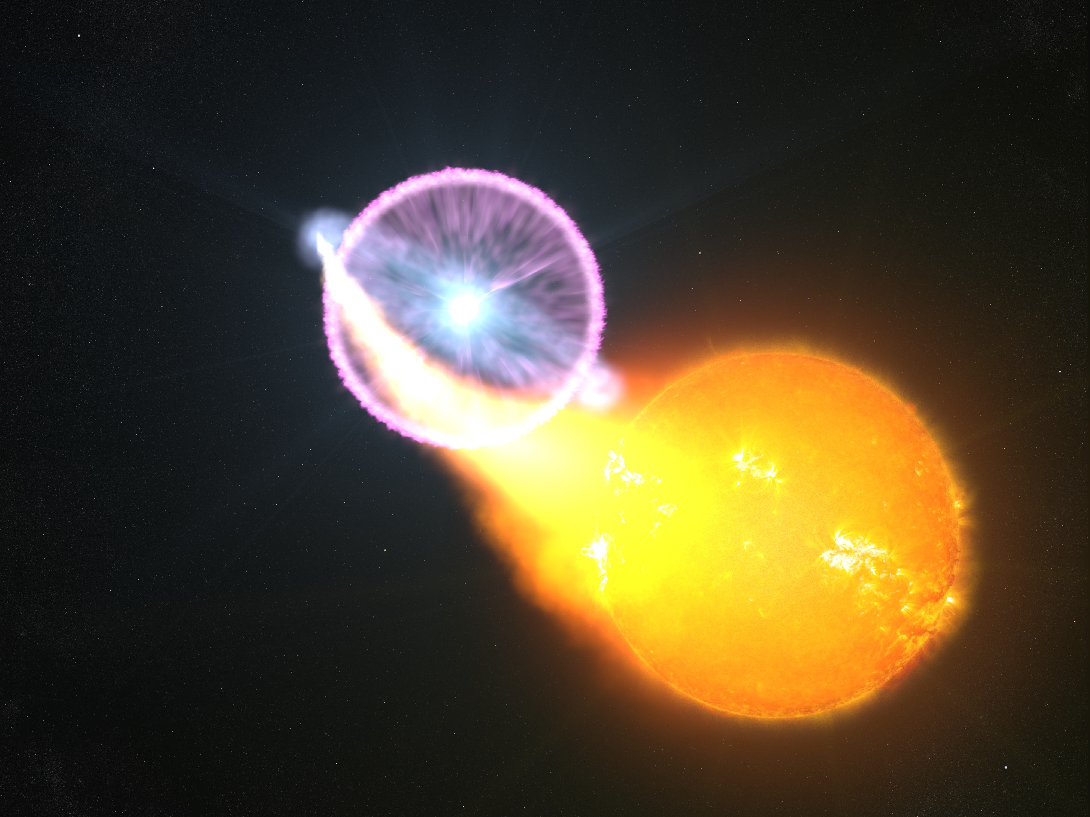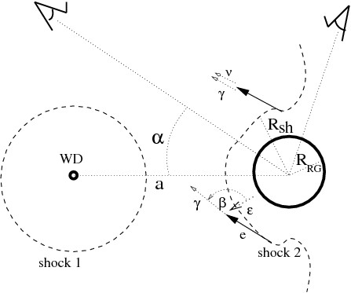

Figure 1.12: *Left:* Artist concept of a classical nova. Credits: NASA’s Goddard Space Flight Center/S. Wiessinger. *Right:* Diagram of the geometry of the symbiotic binary system V407 Cyg from [124]. The expanding shock (1) from the white dwarf partially overtakes the Red Giant (shock 2), producing particle acceleration through IC (leptonic scenario, with angle of interaction *β*) and proton collisions with the red giant wind (hadronic scenario).

Among many SNRs, PWNe and stellar clusters in HII regions, there is also a Super Massive Black Hole (SMBH), Sagitarius A*, whose detection has been one of the major motivations for GC surveys. Many *γ*-ray experiments have surveyed the GC region (*Fermi*-LAT , MAGIC [27], H.E.S.S. [75], VERITAS [32]) and emission from HE to VHE bands has been detected. The main problem with this highly populated region is the difficulty of tell apart individual sources, making it a big challenge to identify the actual emission from Sgr A* [69]. The high energy emission from Sgr A* has its origin in the strong winds produced by the presence of an accretion disk surrounding the black hole, where material is accelerated at very high energies [70].

Closely related to Sgr A* might be the *Fermi bubbles*, two large *γ*-ray lobes that appear to be ejected from the center of the galaxy. They were discovered while searching for a *γ*-ray counterpart to the WMAP haze [128], which is a residual microwave emission that arises after subtracting all the other known emission components. They extend to 55o up and above the GC and are not symmetric, with an enhanced emission towards the south-east side of the bubbles. With well defined edges, an uniform power-law spectrum of index ∼ 2 and a cocoon-like shape, they resemble jet-like structure [22]. Their origin is still under debate: They could be jets, outflows or the result of accretion events from the black hole, winds from SN explosions or the remanent of AGN activity in the Milky Way in the past.

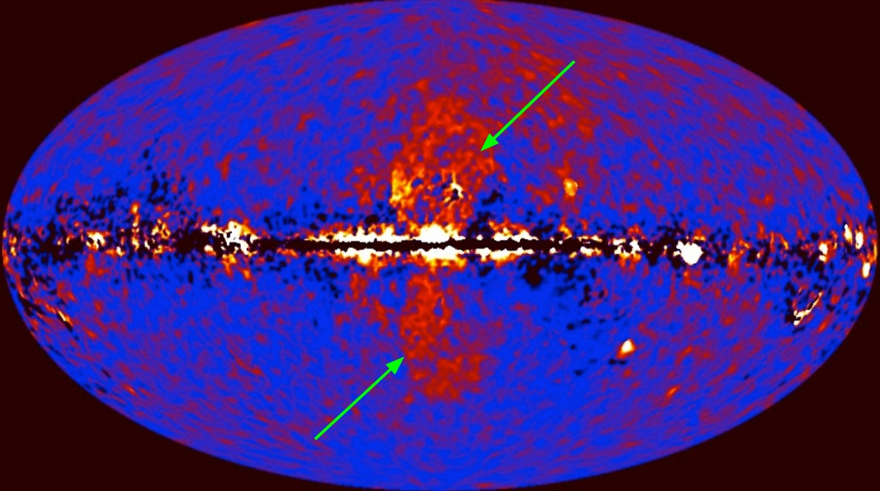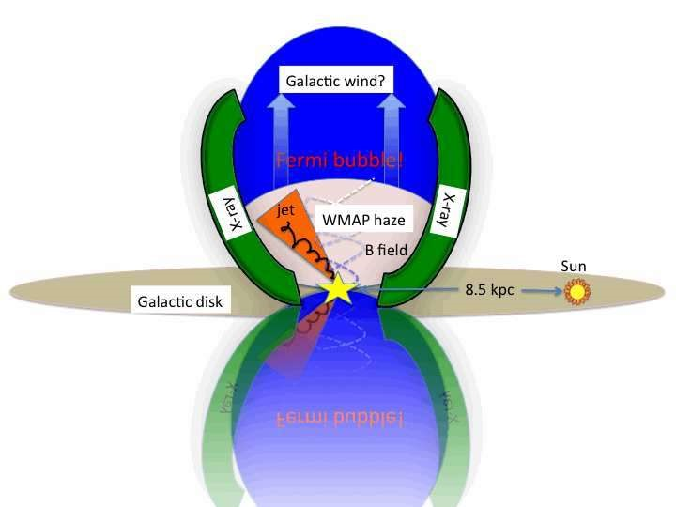

Figure 1.13: *Left:* The Fermi Bubbles as seen by *Fermi*-LAT after subtracting all the other known *γ*-ray components. Credits: NASA/DOE/Fermi LAR/D. Finkbeiner et al. Right: Schematic picture of Fermi Bubbles structure from [128].

Globular Clusters

Globular clusters are compact gravitationally bounded stellar associations with spherical geometry which are distributed outside the galactic plane, conforming a spherical halo around the galaxy. They are old highly evolved systems with many compact objects like neutron stars, white dwarfs and pulsars even forming binary systems. Furthermore, the majority (∼ 80%) of Millisecond Pulsars (MSPs) (pulsars with a period of the order of milliseconds) detected up to date have been found in globular clusters.

Since all the mentioned objects are well known *γ*-ray emitters, globular clusters have been observed and detected in *gamma*-rays by *Fermi*-LAT [2] and H.E.S.S. [73]. Even pulsed *γ*-ray emission have been observed from individual MSPs [62], [142]. Two types of models of *γ*-ray emission have been discussed to happen in globular clusters, both related to MSPs. One takes place in MSPs magnetospheres, where *γ*-ray emission would be produced by curvature radiation. The second type of models involve IC scattering of electrons accelerated close to the MSP with optical, infrared or CMB photons [129].

## 1.6.2 Extragalactic sources

While most of the *γ*-ray emission detected on Earth comes from the galactic plane, there is a big amount of individual sources outside our galaxy which produce HE radiation and allow the study of a new range of extragalactic phenomena. A big caveat for extragalactic sources is that the VHE range is suppressed by the EBL absorption, as described in section 1.4.

Active Galactic Nuclei

AGN are the brightest steady sources of *γ*-ray in the universe and the most luminous known electromagnetic emitters. Known as *black-hole galaxies*, their strong emission is powered by infalling gas into a massive Black Hole (BH) located in the center. The BH attracts gas and material from the galaxy forming an accretion disk, where matter loses angular momentum through viscous and turbulent processes, and emits a huge amount of energy from ultraviolet to soft X-ray bands [133]. AGN can be classified in two broad types, according to their radio emission: *Radio-quiet* and *radio-loud*. Further observational classification depends strongly on the orientation angle, which can make AGNs appear as spectroscopically completely different sources, depending on the region of the object that is showing. All AGN have a dusty tori, broad-line regions, narrow-line regions and strong blue/UV bump emissions from the accretion disk [53]. Depending on the angle, one or several of these regions will be observable and will show their particular features in the spectrum. Figure 1.14 show a scheme of AGNs taxonomy.

Radio-loud AGN, also known as *blazars*, are about three orders of magnitude brighter in radio band than their quiet counterparts. This radio emission is directly related with the presence of relativistic jets of plasma which carries a big part of the energy released during accretion and that afterwards is emitted as radiation from radio to *γ*-rays [96]. They are associated with elliptical galxies that have undergone recent mergers. On the contrary, radio-quiet galaxies doesn’t show jets and so do not account for high energy non-thermal emission. Also, they are typically spiral galaxies in lower density regions [141]. Blazars are rare among AGN, accounting only for 10% of the total, but a large number of them has been detected in *γ*-rays, with more than 1500 sources detected at GeV energies, and more than 60 at TeV energies [53].

Gamma Ray Bursts

GRBs are short and intense flashes of *γ*-ray emission coming isotropically from random directions in the sky. With a range of luminosities from 1051*ergs/cm*2 to 1052*ergs/cm*2 they are the brightest transient objects in the sky [113]. They can be classified by their duration, havign two distinct populations: short GRBs, which last just a few seconds; and long GRBs which can last for few minutes [89]. Long bursts are usually followed by afterglows in X-rays, optical and radio which can last for several years after the event. The so called *fireball* model is the generally accepted mechanism which drives GRB [112]. Since the observed emission of the bursts is not thermal, its origin must be the result of the conversion of an ultra-relativistic energy flow into radiation in an optically thin region. The energy flow could come from the kinetic energy of accelerated particles or electromagnetic Poynting flux. In this model, the process is ignited by an "inner engine" which is not possible to observe directly, but which activity can be characterized by the observed temporal structure of the bursts. The engine produces an explosive fireball of the size of the engine itself. There is an alternative model based in internal shocks, where the engine would produce a wind and a long energy flow. About the nature of the phenomena producing GRBs, there exist an apparent difference between the origin of short GRB and long GRB according on their hardness ratio (defined as the ratio of the flux in two separated bands) versus duration plot (see figure 1.15) [89].

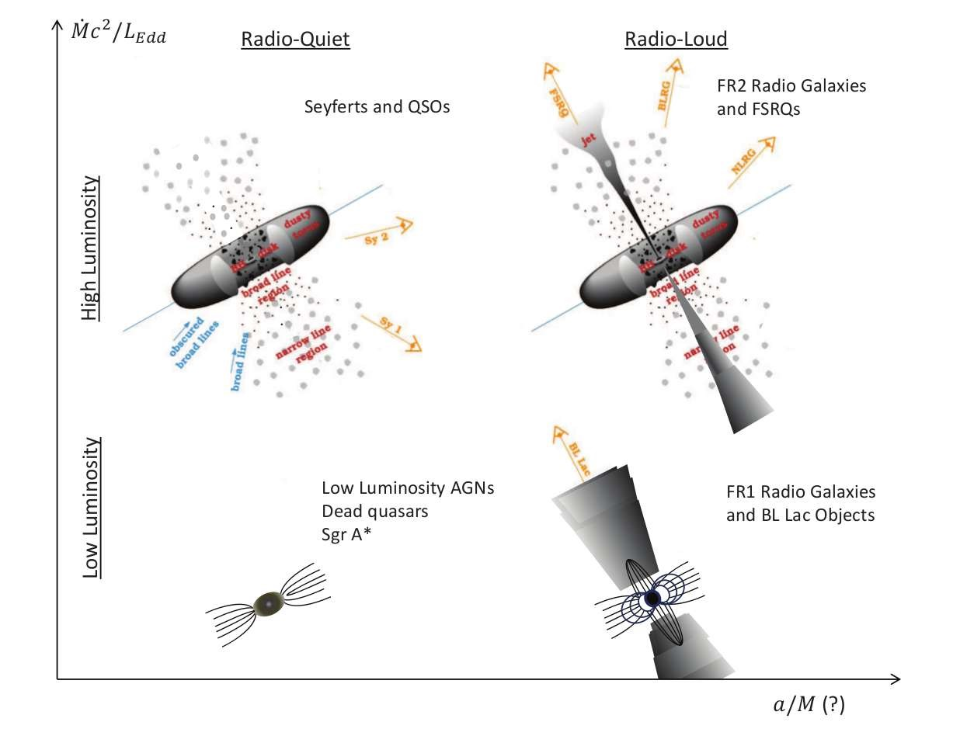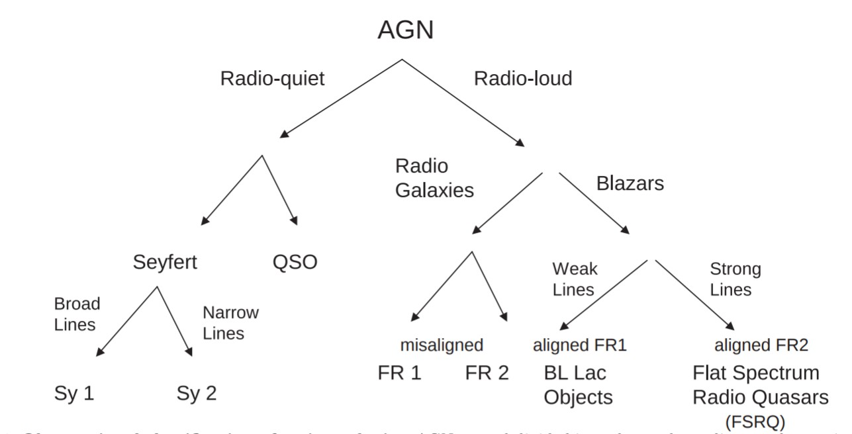

Figure 1.14: Left: AGN taxonomy as from [53]. In this scheme, the vertical axis represents the luminosity power in terms of the mass-acretion rate and horizontal axis represents the BH rotation. Right: Observational calssificartion of active galaxies. QSO= quasi-stellar objects; Sy1(Sy2) = Seyfert 1(2); FR1(FR2)=Fanaroff-Riley 1(2). Pictures based on [134] from [53].

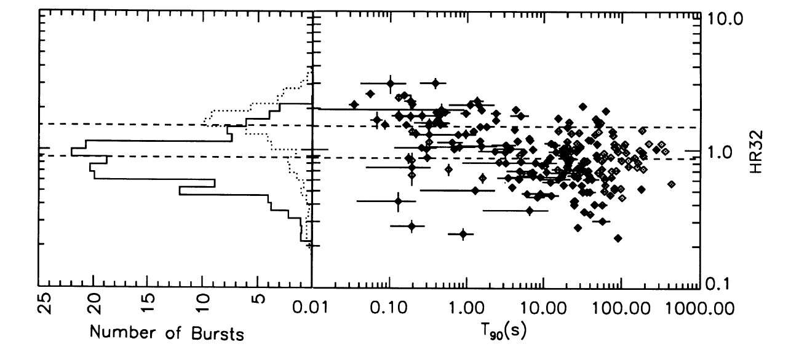

Figure 1.15: *Left:* Hardness ratios for the two duration classes of GRB. Solid lines corresponds to short GRBs, dashed line to long GRBs. *Right:* Hardness vs. duration plot, where duration *T*90 is defined as the time during which the cumulative counts > 25 keV increase from 5% to 95% above background. Dashed lines correspond to the mean hardness ratio of the two classes. Figure from [89].

These two populations in the hardness ratio vs. duration plot, together with rather significant spectral differences [67] and afterglow observations, suggest that long GRBs are closely related to star forming regions, compatible with SN explosions of massive stars. Short GRBs on the other hand, could be related to more evolved regions and be the result of neutron star mergers, such as the recently detected gravitational wave event GW170817 by LIGO/VIRGO [1] which was also detected as a GRB by the Fermi Gamma-Ray Burst Monitor and later observed by *Fermi*-LAT [26]. Also recently MAGIC, which were specifically designed to observe such objects, detected the first event in the VHE range [101].

Starburst galaxies

Starburst galaxies are those with a greatly enhanced star formation, whose Star Formation Rate (SFR) is considered to be out of equilibrium, consuming gas for star formation at very short timescales (< 1 Gyr). Since the SFR is highly correlated with the SN explosion rate, it is expected that *γ*-ray emission detected from starburst galaxies has its origin in SNRs.

The production and transport of CRs in the ISM significantly affects the star formation, because CRs penetrate deep into molecular cloud cores (molecular clouds are dense gas regions where star formation takes place) catalyzing complex chemical reactions which can affect the initial conditions of star formation and evolution [106]. The conditions of the ISM in starburst galaxies are very different from Milky Way [13]. The gas density is much higher and the high population of massive stars produce a huge amount of radiation, which is absorbed by dust an re-emited in infrared. Magnetic fields are also affected by the presence of such population. Thereby particles accelerated in the region will suffer strong losses of energy and faster cooling. Detection of *γ*-rays from starburst galaxies is a key probe to understand the efficiency of CR acceleration in SNRs and CR transport in different ISMs.

The current generation of *γ*-ray telescopes have detected NGC253 and M82 starburst galaxies ([13], [137], [3]), which has been long predicted to emit *γ*-rays up to VHE range.

Galaxy clusters

Galaxy clusters are the largest gravitationally bounded structures in the universe. They are mainly composed of DM (70-80% of the total mass) and their ordinary matter is composed by the galaxies and the filaments connecting them, plus a big amount of hot gas in the surroundings called the Intracluster Medium (ICM)[38]. In the standard paradigm of structure formation, clusters are formed by hierarchical mergers and accretion of smaller structures. Mergers are the most energetic phenomena to occur in the universe (they release 1063-1064 ergs/Gyr) and they dissipate energy in the form of shocks which heat the gas, or through large-scale ICM motions [39]. Part of the energy dissipated during this process is fused into particle acceleration to ultra-relativistic energies, thus they are a source of CR production. Radio observations of galaxy clusters proves the existence of non thermal emission from synchrotron radiation processes in the ICM. Galaxy clusters can therefore be a source of HE photons which can be produced via leptonic scenario through IC scattering of CMB photons with ultra-relativistic electrons, or hadronic scenario by neutral pion decay.

Until recently, *γ*-ray experiments that tried to detect *γ*-ray signal from the closest galaxy clusters were only able to set upper limits [19], [28]. *Fermi*-LAT was able to report a detection of an extended *γ*-ray signal from the Coma cluster roughly correlated with the radio halo [143].

Neighbour galaxies

The Local Group is the cluster of galaxies gravitationally bounded to the Milky Way. They are the closest galaxies to be observed and their characteristics are expected to be similar to those of our own galaxy. The second and third closest and spatially resolved galaxies (the first being the Canis Major dwarf galaxy) are the Large Magellanic Cloud (LMC) and the Small Magellanic Cloud (SMC). They are two irregular dwarf galaxies seen in the southern hemisphere, at a distance of 50 kpc [50]. They present a remarkable high star formation rate (∼ 0*.*2yr−1 for the LMC, 0*.*3yr−1 for the SMC [118], compared to the 0.68yr−1 to 1.45yr−1 of the Milky Way [119] in a much smaller volume.). They can produce *γ*-ray emission due to the interaction of CR with ISM. The first detection of a *γ*-ray diffuse signal from the LMC was made by EGRET [126], being the first normal galaxy outside the Milky Way detected in *γ*-rays. The SMC was first detected in *γ*-rays by *Fermi*-LAT [4]. Further observations of the LMC from *Fermi*-LAT at HE [8], [15], [47] and H.E.S.S. [74], [88] at VHE revealed a complex structure of the diffuse emission and a population of very interesting individual sources comprising pulsars, SNRs, PWNe and *γ*-ray binaries. Since the LMC emission in *γ*-rays is one of the main topics of this thesis, it will be extensively treated in chapter ??.

Apart from the before mentioned starburst galaxies M82 and NGC253, other close galaxies such as M31 and M33 have also been observed and detected in HE *γ*-rays by *Fermi*-LAT [20].

## 1.6.3 Potential Dark Matter annihilation emission sources

In section 1.5 the production of *γ*-rays through WIMP annihilation or decay was described. In the search for this kind of signal, one can analyze which would be the best sources in the universe for an indirect search of DM. First of all, they must have a high amount of DM, given by the astrophysical parameter J-factor (integral term in eq. 1.23). Also, a low background of other *γ*-ray sources would allow to unequivocally identify the DM signal. Following these premises, indirect DM searches have been performed by *γ*-ray experiments in the most promising sources:

Milky Way Galactic Center

In the present evolutionary stage of the universe, galaxies are believed to be embedded in DM halos which extend much more than the visible matter, the center of the galaxies being the location of higher DM density [105]. The center of the Milky Way is therefore a promising target for DM searches. However, as explained in section 1.6.1, it is also a very populated region with many *γ*-ray sources which are even not fully resolved. This fact makes the GC a true challenge for disentangle a possible DM emission, needing a very good background modelling and control of the instrumental systematics [42]. Usually, DM searches in the GC tend to avoid the galactic plane region, observing a region with lower background at expenses of having a weaker DM signal due to the lower density.

The most constraining upper limits in the VHE energy range for the velocity averaged cross section *< σv >* in the GC have been established by H.E.S.S. [9]. Both *Fermi*-LAT and H.E.S.S. have accounted for a *γ*-ray excess coming from the GC of unknown origin which has been tried to be fitted with the most conventional DM models, but the results were not sufficiently compatible [23], [21].

Dwarf Spheroidal Galaxies and Dark Clumps

Following the standard model of cosmology, N-body simulations of the evolution of CDM since the Big Bang predicts a hierarchical structure formation where DM clusters into subhalos which merge into higher structures. The final picture at galactic scales, are galaxies embedded in a big DM halo, surrounded by a population of subhalos with mass inversely proportional to their number [91]. Simulations like Via Lactea II predict that the Milky Way is surrounded by a large number of DM subhalos

(∼ 50*,*000). The heavier of these substructures are the so called Dwarf Spheroidal

Galaxies (DSphe). They are very faint galaxies (in optical) orbiting the Milky Way.

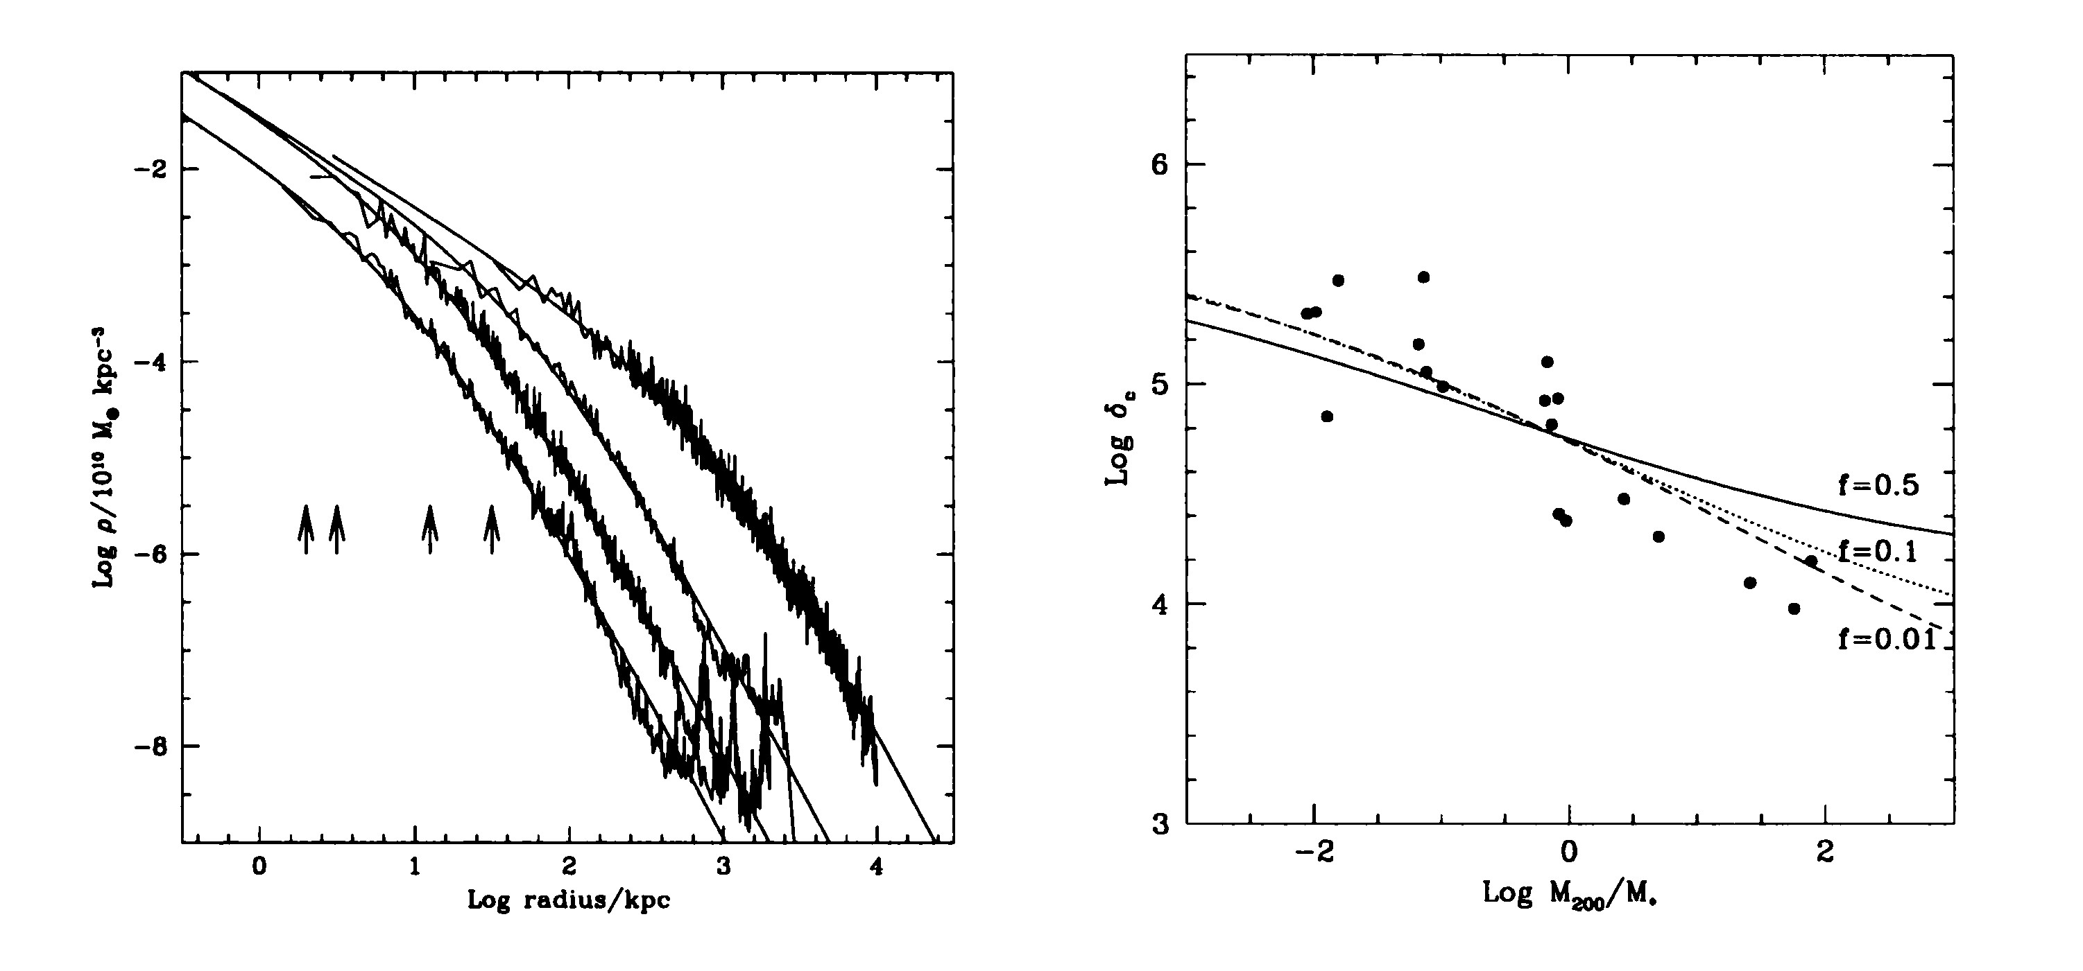

Figure 1.16: *Left:* Typical density profiles from Cold Dark Matter (CDM) halos obtained from N-body simulations. *Right:* Characteristic overdensity of halos as a function of mass. Masses are expressed in units of the current non linear mass corresponding to the standard biased CDM spectrum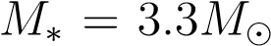. Figures from

[105].

Many of the observed DSphe are strongly DM dominated, but have absent or very little star formation and no signal of ionized or neutral gas [123]. Smaller structures with no emission at all are known as Dark Clumps.

These kind of objects are a perfect target for DM searches because no *γ*-ray signal is expected from them due to ordinary astrophysical processes. Any *γ*-ray detection would be an unequivocal signal of DM annihilation.

The present generation of *γ*-ray experiments have widely studied these objects in the search for DM, not yet being succesful at detection but setting very stringent upper limits on DM models using data from many DSphes ([7], [11],[25], [31], [2019DSpheCombined]).

Galaxy Clusters

As has been mentioned before in section 1.6.2, galaxy clusters are mostly dominated by DM with a very high mass-to-light ratio. For this reason, they are good targets for indirect DM searches both for annihilation and decay. They are specially suitable for decaying DM, since at large volumes the signal of decaying DM which is proportional to the first power of the density overshines the signal of annihilation [44].

Strong constraints for a wide number of models for DM annihilation and decay have been set by *Fermi*-LAT [84], [14] and H.E.S.S. [10], and also constraints on the decaying lifetime of DM were set by MAGIC [12].

The Large Magellanic Cloud

The LMC has been considered a well promising target for DM searches due to its proximity and rather high J-factor ( 1020*J/GeV* 2*cm*−5). Kinematic studies of the LMC show that more than half of the LMC mass is forming a dark halo with a compact central bulge [136], [125].

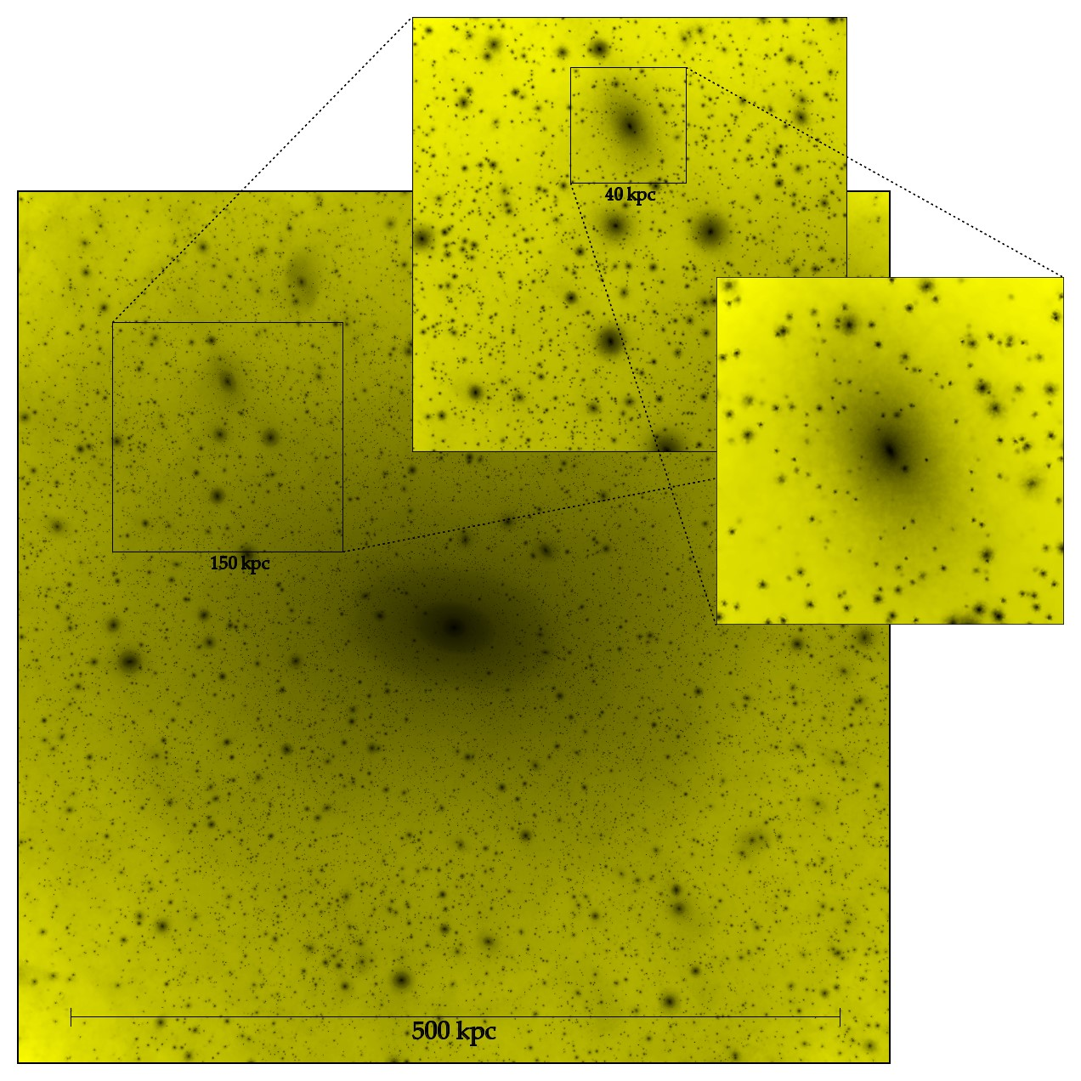

Figure 1.17: Results from *Via Lactea* N-body simulations of DM substructures. The picture show a projection of density squared in a 566 kpc × 566 kpc × 566 kpc region centered on the host halo at z = 0, from [91].

*Fermi*-LAT has used five years of data to set constraints on the DM annihilation signal from the LMC in the HE regime [40]. No limits has yet been set in the VHE range though. As one of the main topics of this thesis, more on this subject will be extensively discussed in chapter ??.

Discoveries in astronomy have always been directly related to technological advances of new instruments and observation techniques. The first telescope was invented by Galileo in *XVII* century and it allowed him to observe for the first time the four brightest moons of Jupiter. Since then, and specially during the *XX* century, a broad new range of experiments, detectors and telescopes have been built either on the ground or in space. Thanks to them, astronomers have observed the universe in every wavelength from radio to *γ*-rays. Furthermore, recently the field of multimessenger astronomy has started a new era, combining light with other cosmic messengers such as neutrinos and gravitational waves.

This chapter is dedicated to the technologies used to detect *γ*-rays, from the history of first detectors, to the present generation and future of *γ*-ray observatories. Contrary to the visible light that Galileo received with his first telescope, *γ*-rays cannot be directly observed from Earth. The atmosphere absorbs most of the radiation coming from space, limiting the range of the spectrum that can be detected with ground based detectors. As shown in figure 2.1, only visible and radio wavelengths reach the ground through the so called *atmospheric windows*, hence *γ*-rays can be observed only from outside the atmosphere, with detectors in balloons or satellites. A description of different types of such detectors and their used techniques is given in section 2.1.



2

. Detection of

*γ*

-

rays

Other possibility is to take advantage of the interactions of *γ*-rays with particles in the atmosphere when they are absorbed. When a *γ*-ray or any cosmic particle hits an atmospheric atom, a large number of secondary particles is produced which themselves suffer further interactions in a cascade reaction known as EAS. More on EAS and ground-based detectors can be found in sections 2.2 and 2.4 respectively.

37

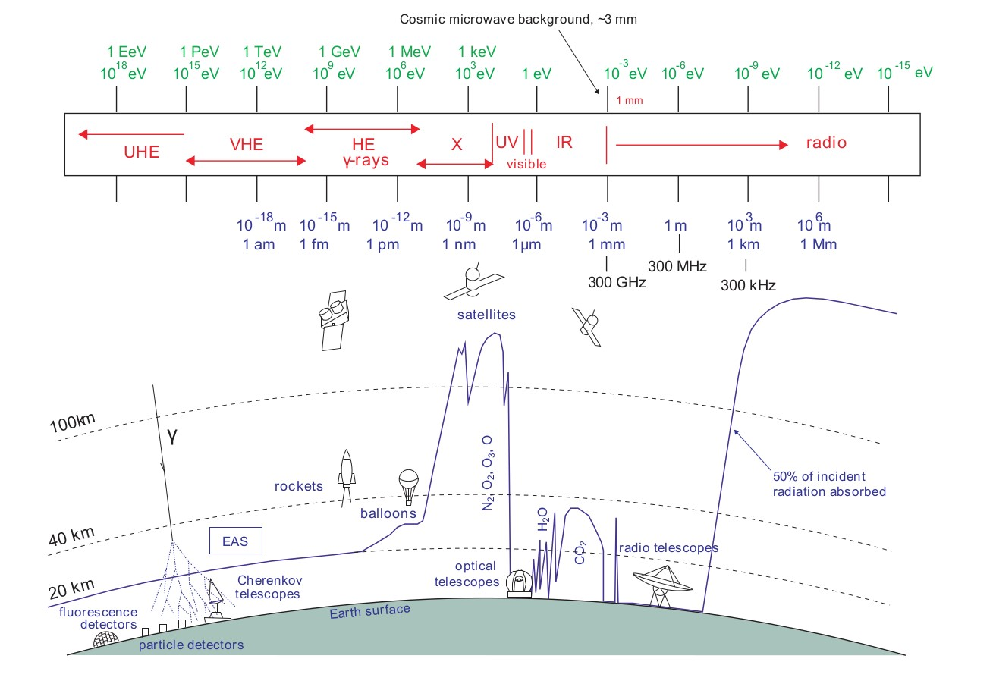

Figure 2.1: Atmospheric transparency for the whole electromagnetic spectrum, from [95]. The continuous line represents the height in the atmosphere where 50% of the light is absorbed.

Space detectors and ground based detectors complement perfectly well, supplying the limitations of one another to cover the full *γ*-ray spectrum. Lower energy *γ*-rays are abundant, but so are hadronic backgrounds (CRs). Space detectors are perfectly suited to study these part of the spectrum, because beside their rather small collection areas (∼ 1*m*2), they have very good background rejection. At higher energies, the *γ*-ray flux decay strongly and much higher collection areas are needed to have competitive detectors. Ground based instruments detect the extended secondary products of *γ*-rays interacting in the atmosphere, they are designed to cover big areas, capturing even events from the highest energy *γ*-rays.

# 2.1 Space detectors

Direct detection of *γ*-rays can only be done outside the atmosphere, with particle detectors mounted in high altitude balloons or satellites. The main advantage of these kind of detectors is the extremely efficient background rejection, being relatively easy to veto charged cosmic particles and distinguish them from neutral *γ* photons.

2.1 Space detectors

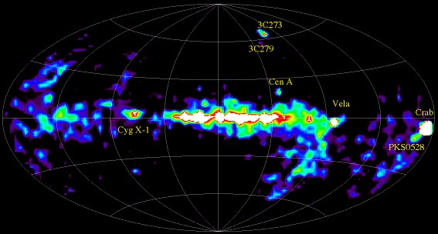

Figure 2.2: Skymap from COMPTEL source catalog. Credits to NASA.

However, they are limited in the energy of the *γ*-rays they can observe, not being able to go much further 100 GeV (HE regime) because of the inability to have a large collection area. The collection area corresponds to the size of the detector, which for space instruments it is about 1 *m*2, making it very difficult to capture VHE photons which flux decreases rapidly with energy.

In this section, different types of space detectors are desribed.

## 2.1.1 Compton detectors

Compton scattering occurs when a photon transfers part of its energy to an electron. At the low end of the *γ*-ray energy range (from 20 keV to 30 GeV) this is the process that dominates interactions between light and matter. Compton detectors are based on this interaction. Usually, they count on two parts: In the first level, the interaction between the *γ* photon and an electron occurs inside a scintillator. The trajectory deviation of the photon is measured, and then is possible to reconstruct its original direction. Afterwards, the photon travels to a second level where it is absorbed by a calorimeter and its energy is measured. The COMPTEL instrument from the Compton Gamma Ray Observatory (CGRO) was operative between 1991 and 2000 and was able to do a survey of the galactic plane using this technique, detecting more than 60 sources (figure 2.2). Currently, the Imager on-Board the INTEGRAL Satellite (IBIS) telescope on board of the International Gamma-Ray Astrophysics Laboratory (INTEGRAL) space telescope is the present representative of this kind of detectors.

## 2.1.2 Pair production detectors

A photon travelling with an energy over twice the rest mass of the electron (511 keV, usually photons over 20 GeV) passing close to a nucleus have a high probability to suffer pair production, meaning it produces an electron-positron pair with kinetic energy. Pair production detectors account for different layers of a heavy material where the interaction takes place, interleaved with a tracker material which measures the position of the resulting particles, being able to reconstruct the original direction of the *γ*-ray. A calorimeter measures the energy of the particles and an anti-coincidence detector acts as veto for the background of charged particles (CRs) which can enter the detector. The latest and most prolific instrument of this kind is the Large Area Telescope (LAT) instrument, on the Fermi Gamma-Ray Telescope which is formerly described in the next section.

The Fermi Gamma-ray Space Telescope

The Fermi Gamma-ray Space Telescope was launched in 2008 with the objective of performing a sky survey in the HE range. It is placed in a low Earth orbit, being able to observe the whole sky in 3 hours. It accounts of two instruments: The LAT, which is the principal instrument for *γ*-ray detection, and the Gamma-Ray Burst Monitor (GBM), which is designed to detect GRBs.

* + The LAT: This is the principal instrument of the Fermi telescope, a pair production *γ*-ray detector able to observe photons with energies between 20 MeV to more than 300 GeV [33]. It consists on 16 modular towers with 18 tungsten converter layers, where the pair production takes place, and 16 dual silicon tracker planes which measures the position of the *e*± pair. The 16 calorimeter modules have 96 long, narrow CsI scintillators which measure the deposited energy. When any particle enter the detector, they first pass through an anticoincidence plastic scintillator where, if it is a charged particle, it will produce a flash of light, making it possible to distinguish background events from true *γ*-ray events.
  + The GBM: Complementary to the LAT, the GBM is destined to detect GRBs

and quickly alert the main instrument to reposition towards the source of interest. It is sensible to X-rays and *γ*-rays in the range between 8 keV to 40 MeV. The detector includes 12 Sodium Iodine (NaI) scintillation detectors which cover the lower part of the spectrum (up to 1 MeV) and provide the burst trigger, and 2 Bismuth Germanate (BGO) scintillation detectors with an energy range from ∼ 150 keV to ∼ 30 MeV, aimed to overlap the LAT energy range.

The principal scientific objectives of Fermi are the study of unidentified sources detected by previous instruments like EGRET; understanding the mechanisms of particle acceleration in SNRs and GRBs; studying the behaviour of GRBs;performing indirect searches of Dark Matter and using *γ*-rays to probe the early universe and cosmic evolution of HE sources.

During the more than 10 years of data taking up to date, the *Fermi*-LAT has been

2.1 Space detectors

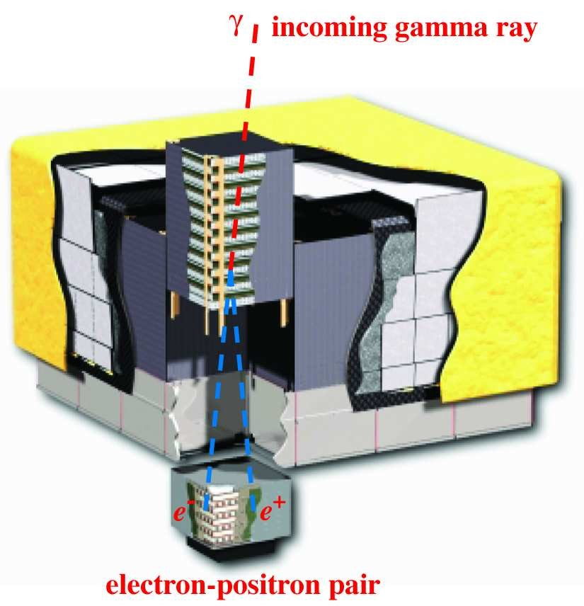

Figure 2.3: Schematic picture of the LAT from [33]. Dimensions are 1.8 m × 1.8 m × 0.72 m.

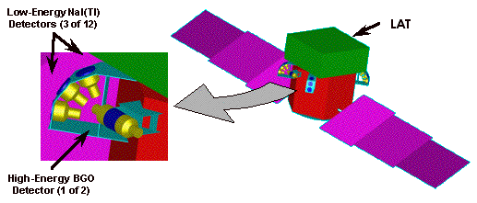

Figure 2.4: Schematic picture of the GBM integrated between the LAT and the shroud envelope of the Fermi’s spacecraft.

extremely prolific, launching several catalogs with thousands of sources. The 4FGL catalog is the last one released, based on the first 8 years of science data. It counts with 5065 detected sources above 4 sigma, 1337 of which do not have a counterpart in other wavelengths.

Some of the scientific highlights during its lifetime are the discovery of the mysterious Fermi Bubbles (see section 1.6.1); the detection of hadronic signals in SNRs [16];the detection of the most luminous GRB ever observed GRB130427A [18] and the detection with the GBM of the GRB after the LIGO event GW170817 [68], among many more.

# 2.2 Extensive Air Showers

As explained in the beginning of this chapter, the atmosphere absorbs the totality of the *γ* radiation coming from space. Any *γ*-ray entering the atmosphere will interact with an atomic nucleus triggering the production of a cascade of particles known as EAS. Furthermore, not only *γ*-rays can produce EAS, but CRs too, being in fact the responsible for the majority of EAS happening in the atmosphere (> 99%). The products of these cascades, whether being secondary particles or Cherenkov radiation (see section 2.3), are the targets for ground based *γ*-ray detectors. Depending on the type of detector, different techniques are required to reconstruct the energy and direction of the primary particle, in addition to distinguish between electromagnetic (produced by *γ*-rays) and hadronic (produced by CRs) showers. In this section, the characteristics and physical processes produced in the different types of EAS are described.

## 2.2.1 Electromagnetic Showers

When a primary *γ*-ray enters the atmosphere, it will produce a pair of *e*± in the electric field of an atomic nucleus, typically after traversing one radiation length (*ξ*0 defined as the mean distance for a charged particle to reduce its energy by a factor *e* due to interactions with the medium), at about 20 km of altitude. This pair of particles, emitted in the forward direction will again interact with other atmospheric nuclei through bremsstrahlung, producing high energy photons. The result is a chain of pair production-bremsstrahlung processes, where a certain amount of energy is lost in each interaction, until the high energy photons reach a critical energy *Ec* ∼ 83 MeV. When this happens, ionization and Compton scattering of electrons and positrons become dominant over bremsstrahlung so the production of high energy photons is reduced until the shower slowly dies. Since the angle of emission in all the processes is proportional to ∝ *mec/E* rad, the shower will not spread too much laterally, from an axis pointing towards the primary direction [139].

To understand in a simple way the evolution of the shower, It can be considered that it develops in discrete steps of one radiation length, just as in the model from [78]. The radiation length for the *e*± pair is going to be close to the mean free path of photons of similar energy (' 9*/*7*ξ*0) which for the air is 36.7 g cm−2. Defining the

2.2 Extensive Air Showers

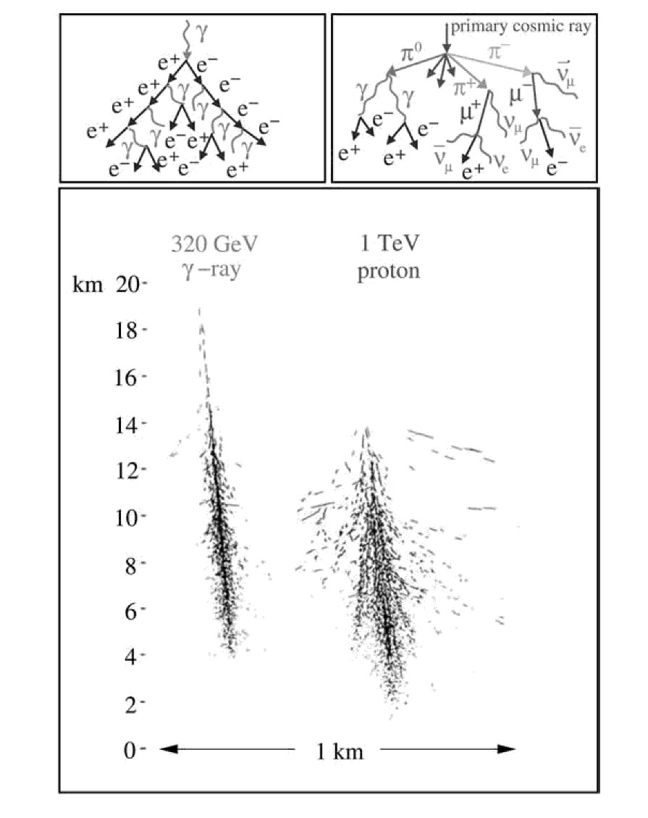

Figure 2.5: Montecarlo simulations of a 320 GeV *γ*-ray shower and a 1 TeV proton shower from [139]. The top panel show a schematic diagram of shower development with their secondary particles.

atmospheric thickness as R=*ξ*0*ln*2, the probability of a photon, electron or positron of the shower to interact while traversing a longitude R will be exp(-R/*ξ*0) = 1/2. Since the distribution of energy in each step between the charged particles and the emitted high energy photon is considered symmetric, after traversing a thickness nR, the number of surviving *e*± and photons will be 2*n*, and their mean energy *Eγ/*2*n*, where *Eγ* is the energy of the primary *γ*-ray. When the energy reaches the critical energy *Ec*, the shower has reached the shower maximum, where the total number of particles is *Eγ/Ec*. The position of such maximum is:

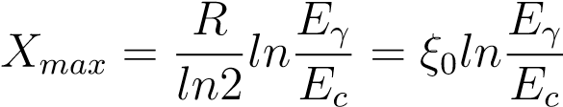 (2.1)

The shower maximum depends on the energy of the primary: higher energy photon showers penetrate more deeply in the atmosphere than lower energy showers, hence in order to lower the energy threshold of a ground based detector it must be located at high altitudes.

An analytical approach to shower development was carried out in [120]. The Greisen equation defines the number of electrons, positrons and photons in the shower before reaching the critical energy:

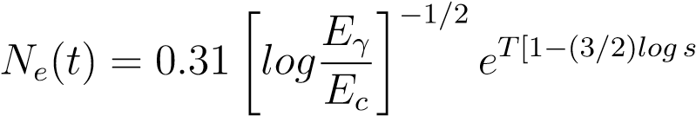 (2.2)

Where T is defined as the atmospheric depth expressed in radiation lengths, and s is the shower age parameter:

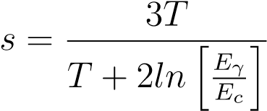 (2.3)

The age parameter s indicates the degree of development of the shower, being equal to 0 at first interaction, 1 in the shower maximum and 2 in the dying point. While *Ne* describes the longitudinal distribution of the shower, the lateral distribution is given by the Nishimura-Kamata-Greisen function:

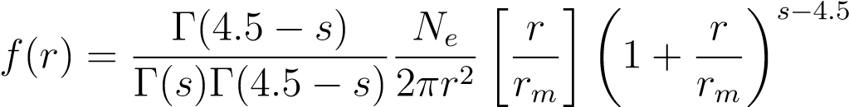 (2.4)

Where r is the distance from the shower longitudinal axis and *rm* is the Molière radius, characteristic from multiple scattering theory, and Γ is the gamma function.

2.2 Extensive Air Showers

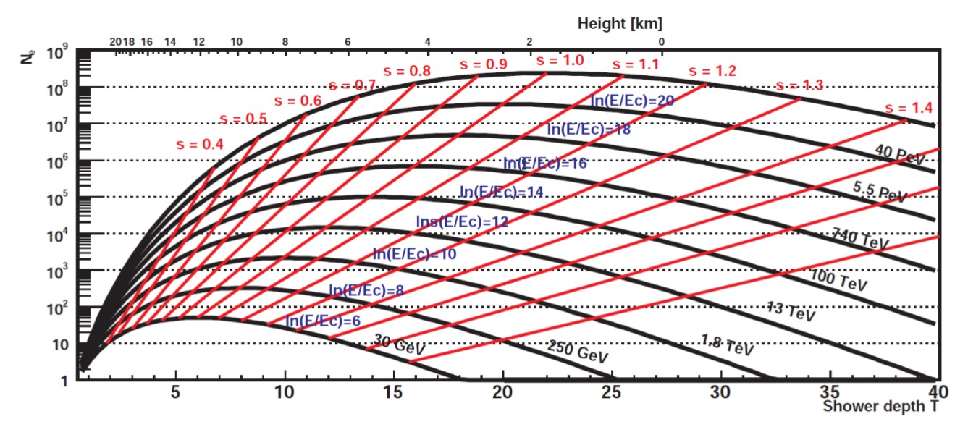

Figure 2.6: Longitudinal development of an electromagnetic shower in the Greisen approximation, from [135] and [46].

## 2.2.2 Hadronic showers

Hadronic showers are produced by CRs, mostly protons, colliding with atmospheric particles. Their development is substantially different from electromagnetic showers, since they produce a vast number of secondary particles of different nature (see figure 2.5) mainly fragments of atomic nucleus, pions and kaons, which end up decaying into muons and neutrinos. Hadronic showers have three components:

* Hadronic core: In the first interaction, a relativistic CR collides with a nucleus (O, N...) fragmenting it into smaller nucleons and transferring energy to them, which on their side keep colliding with other particles. They also produce charged mesons in each interaction (*π* and K mesons). Hadronic interactions will continue until the energy per nucleon becomes smaller than the pion production threshold around 1 GeV.
* Electromagnetic component: Around 90% of the particles generated in hadronic showers are pions, of which 1/3 are *π*0. Neutral pions decay into two HE photons which generate pure electromagnetic showers. Charged K mesons can also decay into neutral pions through *K*± −→ *π*± + *π*0.
* Muon and neutrino component: Charged mesons can also decay into muons and neutrinos through *µ*± −→ *νµ*(*νµ*). Muons traversing the atmosphere will only lose energy through ionization due to their long life and their small bremsstrahlung cross-section. They will decay into electrons/positrons and neutrinos through *µ*± −→ *e*± + *νe*(*νe*) after a time of 2*.*2 · 10−8 s in their own reference frame, but due to their high Lorentz factor, time dilation can make them reach ground level without decaying at all.

Despite their complexity, a model can be assumed to describe the evolution of hadronic showers, similar to the one for electromagnetic EAS. In the superposition model from [65] it is assumed that the shower induced by a nucleus of mass A and energy *E*0 is equivalent to A independent nuclei of energy *E*0*/A*. The shower maximum in this case would be:

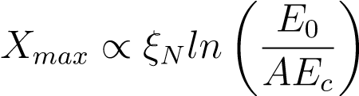 (2.5)

Where *Ec* is the critical energy and *ξN* is defined as the mean path which reduces the number of relativistic charged particles by a factor 1/e as they pass through matter, which for a proton of 1 TeV is 83 g*cm*−2. Because *ξN* is larger than the radiation length for photons *ξ*0, the altitude of first interaction of hadronic showers is higher than electromagnetic showers and they are able to penetrate deeper into the atmosphere. Furthermore, hadronic interactions are able to transfer considerable transverse momentum to the secondary products of the showers making them to disperse laterally. Also, hadronic showers are more irregular and present large fluctuations. These features are used in detectors to distinguish between electromagnetic and hadronic induced showers.

## 2.2.3 Electronic showers

There exist a third type of EAS produced by cosmic electrons and positrons entering the atmosphere. The type of cascade produced is very similar to electromagnetic showers, since the same processes take place: The electron/positron produces HE photons via bremsstrahlung while interacting in the electromagnetic field of atmospheric nuclei and those resulting photons produce *e*± pairs. The main differences with electromagnetic showers have to do with the nature of the primary: Since it is a charged particle, interactions start just when it enters the atmosphere so the shower maximum is reached at higher altitudes. Also, it will be more affected by the deviations produced by the geomagnetic field of the Earth.

# 2.3 Cherenkov radiation

The Cherenkov radiation is a kind of electromagnetic radiation which is emitted when a charged particle travels through a dielectric medium at a velocity higher than the local speed of light. It was well observed during the *XX* century when a transparent material was placed in the neighbourhood of strong radioactive sources, in the form of a faint bluish light. From 1934 to 1938 Pavel Alekseyevich Cherenkov carried out a series of exhaustive experiments to try to explain the causes of this effect and was awarded with the Nobel Prize in 1958 for his results.

Cherenkov radiation is a very important effect for ground-based *γ*-ray detectors

2.3 Cherenkov radiation

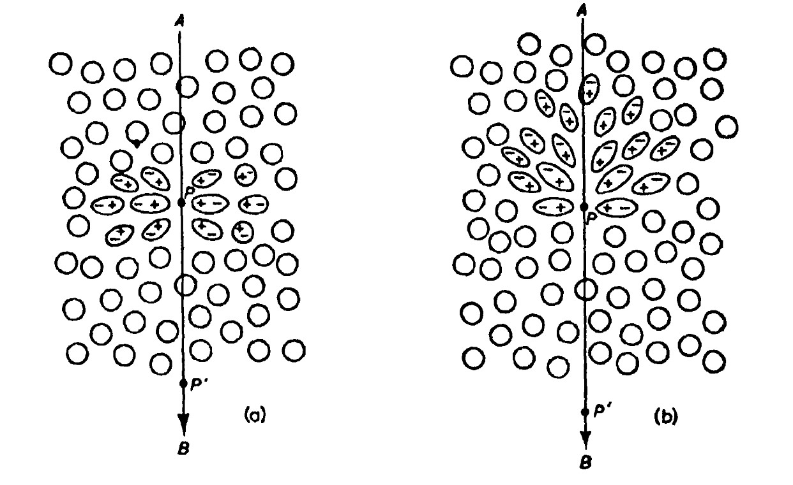

Figure 2.7: Polarization of a dielectric material at the passing of a charged particle by the point P at a) low velocity b) high velocity. Image from [86].

because EAS, which contain a large number of relativistic charged particles, are able to produce this kind of radiation in the atmosphere. Characterization of the Cherenkov signal from EAS allow to trace back the nature of the primaries.

This effect can be explained through the reaction of the atoms of a material when a charged particle is traveling through it. For example, in the case of an electron travelling through a glass, if the electron is travelling at a slow velocity, along its trajectory the electric field of the particle will distort the atoms, attracting the positively charged nucleus and repelling the negative electrons (see figure 2.7 a). The medium becomes polarized around the position of the particle, each atom behaving like a dipole and the region of the glass receiving a small electromagnetic pulse. Since the distribution of dipoles is symmetric, there will not be a resulting field thus no radiation will be emitted.

In the case the electron travels almost at the velocity of light in the medium the resulting field is not symmetric anymore along the direction axis of the particle (see 2.7 b). The dipole field will be noticeable even at long distances and the electron will produce the emission of wavelets of radiation at each point of its trajectory. In general, those wavelets will interfere destructively so that the resulting intensity of the field will be zero. If the velocity of the electron is higher than the speed of light in the medium, the wavelets can be in phase and produce a global field visible in the distance and thus, emit radiation. Figure 2.8 shows a diagram of a Huygens

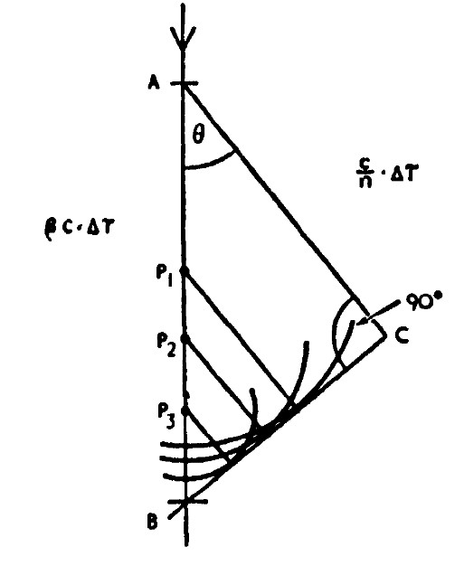

Figure 2.8: Diagram of Huygens construction showing coherence of waves emitted by a charged particle travelling faster than the speed of light in the medium, from [86].

construction of this effect. If a particle travels from A to B faster than the speed of light in the medium, it can travel that distance in the same amount of time that light will go from A to C, therefore when seen under an angle *θ* all the waves emitted along the trajectory will be in phase and form a plane wave from B to C.

The angle *θ* is named Cherenkov angle and can be expressed as:

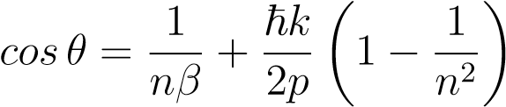 (2.6)

Where *β* = *v/c*, k is the emitted photon momentum, p is the charged particle momentum and n is the refractive index of the medium. Since p k, the expression can be simplified to:

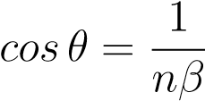 (2.7)

The Cherenkov light produced by EAS in the atmosphere will be emitted in the shape of a cone around the axis of the shower, leaving a ringlike signal when reaching

the ground. Because the refractive index of the atmosphere changes with altitude, the maximum angle will also vary and so the extension of the ring and the minimum energy required by a particle to produce Cherenkov radiation (when v = c/n). The variation of the refractive index with altitude can be approximated by:

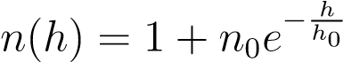 (2.8)

Where *n*0 is 2.9 ×10−4 and *h*0 = 7*.*1*km* for an isothermal atmosphere, and the minimum energy:

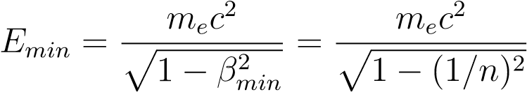 (2.9)

Hence the minimum energy as a function of altitude:

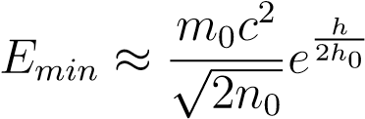 (2.10)

and the maximum angle *θ*:

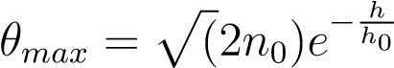 (2.11)

This dependency means that at higher altitudes, the maximum angle is lower, so the Cherenkov signal in the ground will be less spreaded. Also, the minimum energy lowers with altitude, meaning that more developed EAS will more likely produce Cherenkov light.

About the spectrum of Cherenkov light in the atmosphere, while it could go from infrarred to ultraviolet, photons below 290 nm are absorbed by ozone (*O*3), and over 800 nm by *H*2*O* and *CO*2. Also if suffers Rayleigh dispersion and aerosol dispersion.

As a result, the peak of the spectrum at a detection altitude of about 2km is around

300 nm (blue light). The Cherenkov spectrum produced by a particle with charge z and velocity *β* is:

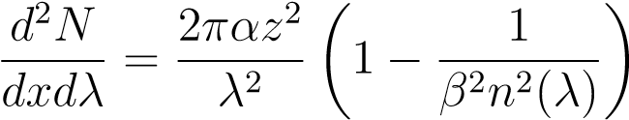 (2.12)

# 2.4 Ground-based detectors

Ground-based detectors work capturing the products of EAS generated by primary *γ*-rays in the atmosphere. As explained in previous sections, EAS produce a cascade of particles which at the same time, emit Cherenkov light. There are two main types of ground based detectors: Particle detectors, which capture the particles produced in the shower, and Cherenkov detectors, which measure the Cherenkov light. Because both *γ*-rays and CRs produce showers, the biggest challenge for ground based detectors is to differentiate the two kinds of events, being less efficient than for space detectors. A proper knowledge of the differences in the development of electromagnetic and hadronic showers is crucial for this task. In general, ground based instruments take advantage of very precise Montecarlo simulations of EAS to find features in the signals which can help to the *γ*/hadron separation.

## 2.4.1 Particle detectors

Particle detectors measure the particles and secondary photons produced by EAS. Because the shower maximum depends on the energy of the primary, as seen in equation 2.1, only *γ* rays with extremely high energies can produce showers that reach the ground. In order to lower the energy threshold of detectors is necessary to place them at high altitudes (over 2000 m).

* Particle counter matrices detectors are classic particle detectors which record the arrival time of particles and direction to reconstruct the shower and eventually the primary characteristics. Examples of this kind of experiments are CASA-MIA [37], LHAASO-KM2 [54], Tibet-AS [85] and HEGRA [60].
* Water Cherenkov detectors are other kind of particle detector. They consist on a large number of big water tanks where particles from the shower produce Cherenkov light. ARGO-YBJ [55] and HAWC [103] are examples of this kind of detector.

The advantage of particle detectors is that they can be extended over hundreds of square meters, covering a very wide field of view. Also, they can work anytime, even under daylight. In general they cover the higher energy range, being able to reach hundreds of TeV.

## 2.4.2 Imaging Atmospheric Cherenkov Telescopes (IACT)

Cherenkov photons produced by EAS in the atmosphere account for 10−4% of the Night Sky Background (NSB) and they can be observed from the ground as flashes of around 10 ns. They require very clear and dark moonless nights, unlike particle detectors. There are two types of atmospheric Cherenkov telescopes:

Sampling detectors

They consist on a grid of counters which measure the Cherenkov light from EAS at ground level with low-gain Photomultiplier Tube (PMT). The direction of the primary can be determined measuring the timing signals from the photons detected, and the energy is reconstructed from the lateral distribution of the Cherenkov light.

The energy threshold for these kind of detectors is high, being suitable for the study of VHE and Ultra High Energy (UHE) *γ*-rays. For example the minimum energy threshold of the Air shower Observation By angle Integrating Cherenkov Counters (AIROBICC) is 20 TeV. For sampling detectors, differentiating *γ*-ray showers from hadronic is truly problematic, and currently they have been outperformed by Imaging Atmospheric Cherenkov Telescopess (IACTs).

Imaging Atmospheric Cherenkov Telescopes

IACTs are the most prolific type of ground based *γ*-ray detectors and their evolution is the key for the next generation of VHE *γ*-ray astrophysics.

They work similar to optical telescopes, with big mirrors which collect Cherenkov light into a camera, where they record images of the showers. Because Cherenkov light flashes are very short, cameras need to be very fast to take snapshots of just a few nanoseconds. Also, as NSB is very high compared to the small number of Cherenkov photons, is essential to have a very precise time correlation between camera pixels, given by very sophisticated state-of-the art electronics, to reject random signals from NSB and get the time evolution of the showers.

The reconstruction of the primary photon and the separation of *γ* and hadron events can be done through a parametrization of the shower images, based on the work done by Michael Hillas [81]. With this method, moments of the light distribution in the camera, which for *γ*-rays look like an ellipse (named Hillas ellipse) are used as parameters to characterize the shower and allow to distinguish between *γ* and hadronic showers. The quantity of Cherenkov light in the image is directly proportional to the energy of the primary and the orientation of the ellipse can be used to reconstruct their direction of arrival. Several techniques are used to reconstruct the primary information from Hillas parametrization, most of them based on modern Machine Learning algorithms.

Other techniques further use the entire information of the camera image, comparing pixel by pixel with a template generated by a semi analytical model of shower development.

A detailed summary on reconstruction methods for Cherenkov Telescopes can be found in [51] and [52].

Either of the techniques improve substantially when using stereoscopy, taking shower images with several telescopes at the same time. Not only it improves the reconstruction power but also helps rejecting the hadronic background very efficiently. For example, when pointing the telescopes to a *γ*-ray sources, in general, shower images from *γ* primaries will be oriented towards the center of the camera (the position of the source) in all telescopes. Hadronic showers, which come from random directions in the sky, will point towards random directions in the camera, so they can be easily discarded.

The first telescope of this kind was the Whipple Observatory 10m reflector [87],

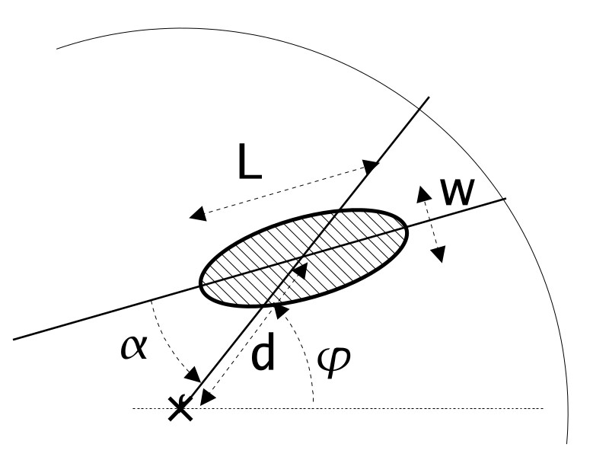

Figure 2.9: Geometrical definition of the Hillas parameters. L for Length (W for

Width) is the RMS spread of light along the major(minor) axis of the image, it carries information of the longitudinal(lateral) development of the shower. Nominal distance d is the angular distance between the centre of the camera and the image centre of gravity. Angle *φ* is the azimuthal angle of the image major axis and orientation angle *α* is the angle between the major axis and the center of the camera. Figure from [51].

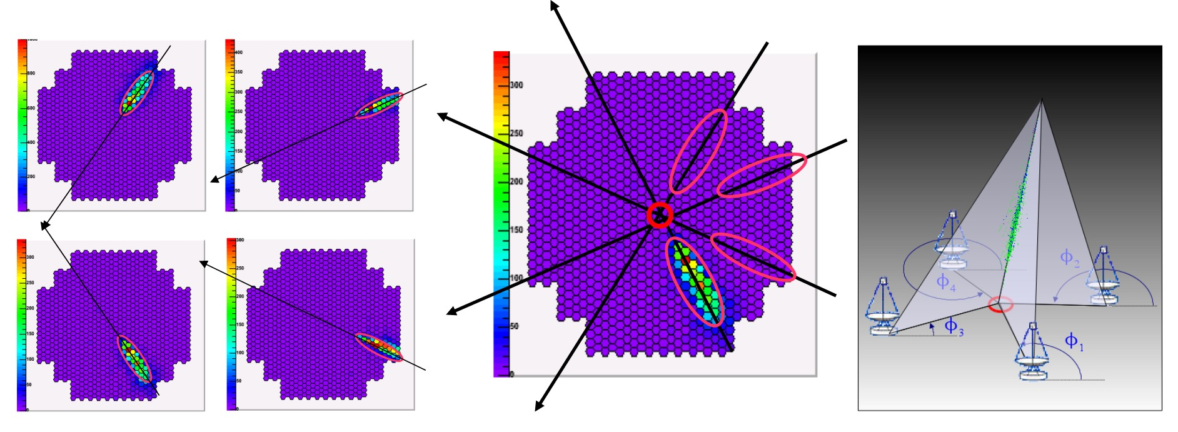

Figure 2.10: Geometric reconstruction of shower direction in stereo mode, from [52]. *Left and middle*: The shower image from 4 telescopes is combined to get the source position in the intersection of the main axis. *Right*: Intersection of the planes which contain the shower tracks and the telescopes give the shower Impact Parameter on the ground.

with a camera of 37 pixels. It started operations in 1968 but it wasn’t until 1988 that they detected the first *γ*-ray source, the Crab Nebula. The first stereoscopic system was the High Energy Gamma Ray Astronomy (HEGRA) complex, with a total of six IACTs which worked together with other types of *γ*-ray detectors (like the AIROBICC).

The current generation of IACTs is formed by MAGIC [48], H.E.S.S. [116] and VERITAS [63] telescopes:

* MAGIC: The MAGIC telescopes are a set of two IACTs of 17 m diameter, located in the Roque de Los Muchachos Observatory at the Canary Island of La Palma, Spain. They are at an altitude of 2200 m, separated by 85 m. The first telescope, MAGIC-I, started operations in mono mode in 2004, and in 2009 the second telescope, MAGIC-II was included, becoming an stereoscopic system. An upgrade was made during the years 2011-2012, to reduce differences between both telescopes and improving the stereo performance.

The energy threshold of MAGIC can reach 25 GeV when using the *sum trigger* setup, becoming the most sensitive IACT system below 300 GeV in the northern hemisphere.

Due to their big size, the MAGIC telescopes are specially well suited to observe low energy events, which produce less Cherenkov photons and require bigger mirrors. This characteristic makes them specially ideal for observing high redshift AGNs and pulsars. Also, they were designed to be very light in order to be able to do a fast repositioning to follow up GRBs alerts. The MAGIC collaboration announced the first detection of a GRB in January 2019 [101]. During their fifteen years of operations the MAGIC telescopes have given prolific scientific results such as the detection in VHE of the PWN 3C 58, the one with the lowest luminosity and lowest flux ever detected in VHE *γ*-rays; the observation of *γ*-ray emission from a jet originated inside the event horizon of the central BH of the galaxy IC 310; the detection of the galaxy PKS 1441+25, one of the two most distant galaxies detected at high energies; the detection of the Crab pulsar, located inside the well known Crab PWN; the detection of *γ*-rays from a gigantic explosion occurred in the galaxy QSO B0218+357 thanks to gravitational lensing; and the tracing of the source (the active blazar XS 0506+056) of a very rare cosmic neutrino event detected by IceCube experiment on September 2017 [97].

* H.E.S.S.: An array of 5 telescopes located in Namibia, close to the Gamsberg mountain, being the only IACT observatory in the southern hemisphere. The first four telescopes, operational since 2004, have 12 m diameter and are arranged in a square shape. The second phase of the experiment consisted in a fifth telescope of 28m of diameter, sitting in the center of the square. It was inaugurated in 2012 and contributed to lower the energy threshold. An update in the cameras of the small telescopes was performed during the years 2015-2016 improving the performance of the whole array.

The energy range of H.E.S.S. goes from 30 GeV to 100 TeV, being the widest of IACT observatories.

Because it is located in the South, H.E.S.S. has been able to perform a galactic plane survey in VHE range, complementary to the HE survey done by *Fermi*LAT (see picture 2.11). Some important scientific highlights of H.E.S.S. are the detection of the Vela pulsar and the colliding wind binary system Eta Carinae; the discovery of new SNRs in the galactic plane; the detection of VHE emission from the LMC P3 binary system discovered by *Fermi*-LAT, with a binary phase of ∼ 0.3, being the most luminous binary system detected up to date; direct measures of the EBL spectral density thanks to the observations of a large number of AGN spectra; and observation of flares and variability in the AGNs Mrk 501 and 3C 279. A detailed summary on these topics among many more scientific highlights of H.E.S.S. can be found in [116].

* VERITAS: Is an array of four IACTs located in the Fred Lawrence Whipple Observatory in southern Arizona. They are 12 m diameter telescopes arranged in a diamond shape and their design is based on the original Whipple 10 m Telescope. The first light of the VERITAS prototype was in 2004 and the full array started operations in 2007. In 2012 the cameras PMTs were upgraded to high-quantum-efficiency PMTs. The total energy range goes from 85 GeV to 30 TeV. Among the most important scientific results from VERITAS are the detection of pulsed emission from the Crab pulsar; Regarding the observations of blazars (AGN), the detection of rapid variability in the blazar BL Lacertae, the detection of the high redshift blazar (z ∼ 0.6) PKS 1424+240 above 0.1 TeV, the discovery of the source VER J0521+211 and deep observations of the distant 1ES 0229+200 (z = 0.14); the survey of the Cygnus region which allowed to resolve new sources and contributed with new candidates of counterparts at TeV energies to *Fermi*-LAT sources in the region. A summary on the most recent VERITAS highlights can be found in [63].

The future of ground based *γ*-ray astronomy is in hands of the Cherenkov Telescope

Array (CTA) currently in construction. CTA will be a *γ*-ray observatory without precedents, as the result of combined efforts of scientists from all over the astroparticle physics community. It will have two locations, one observatory in the northern hemisphere in the island of La Palma, Spain, and the other in the south, in the Atacama desert, Chile. This will allow to do full sky observations, with a sensitivity one order of magnitude better than the current generation of IACT observatories (see figure 2.12). An extended summary on CTA can be found in chapter ??.

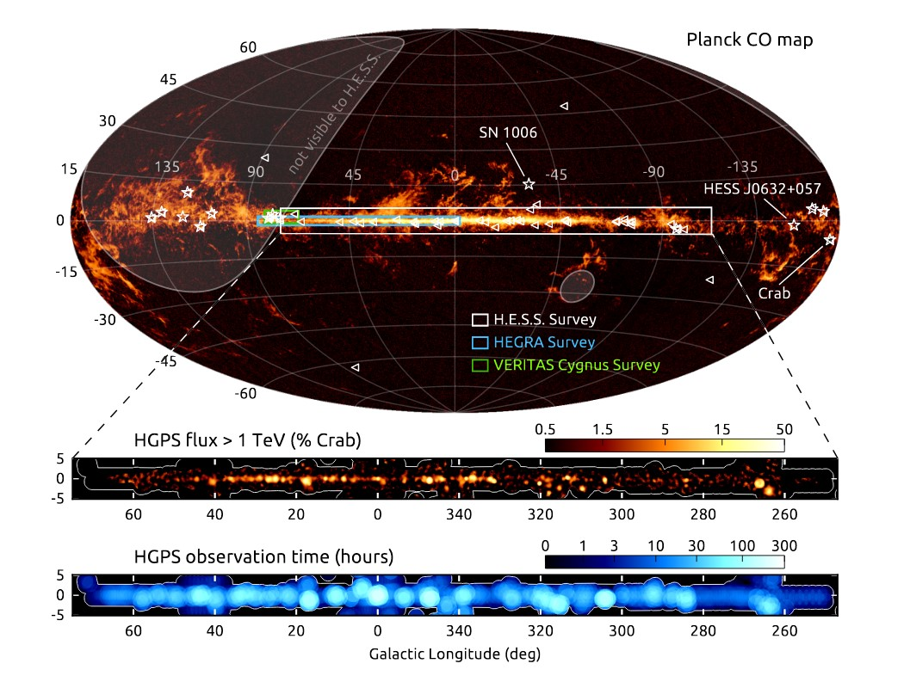

Figure 2.11: Illustration of the H.E.S.S. I galactic plane survey. The region surveyed is shown in the top panel as a white rectangle on top of the carbon monoxide gas sky map measured with the Planck satellite. Previous surveys from HEGRA and VERITAS are also represented. Triangles are sources detected at lower energies by *Fermi*-LAT and stars are galactic sources detected outside the survey region. Middle and lower panels show the observed flux and observation time. Picture from [116].

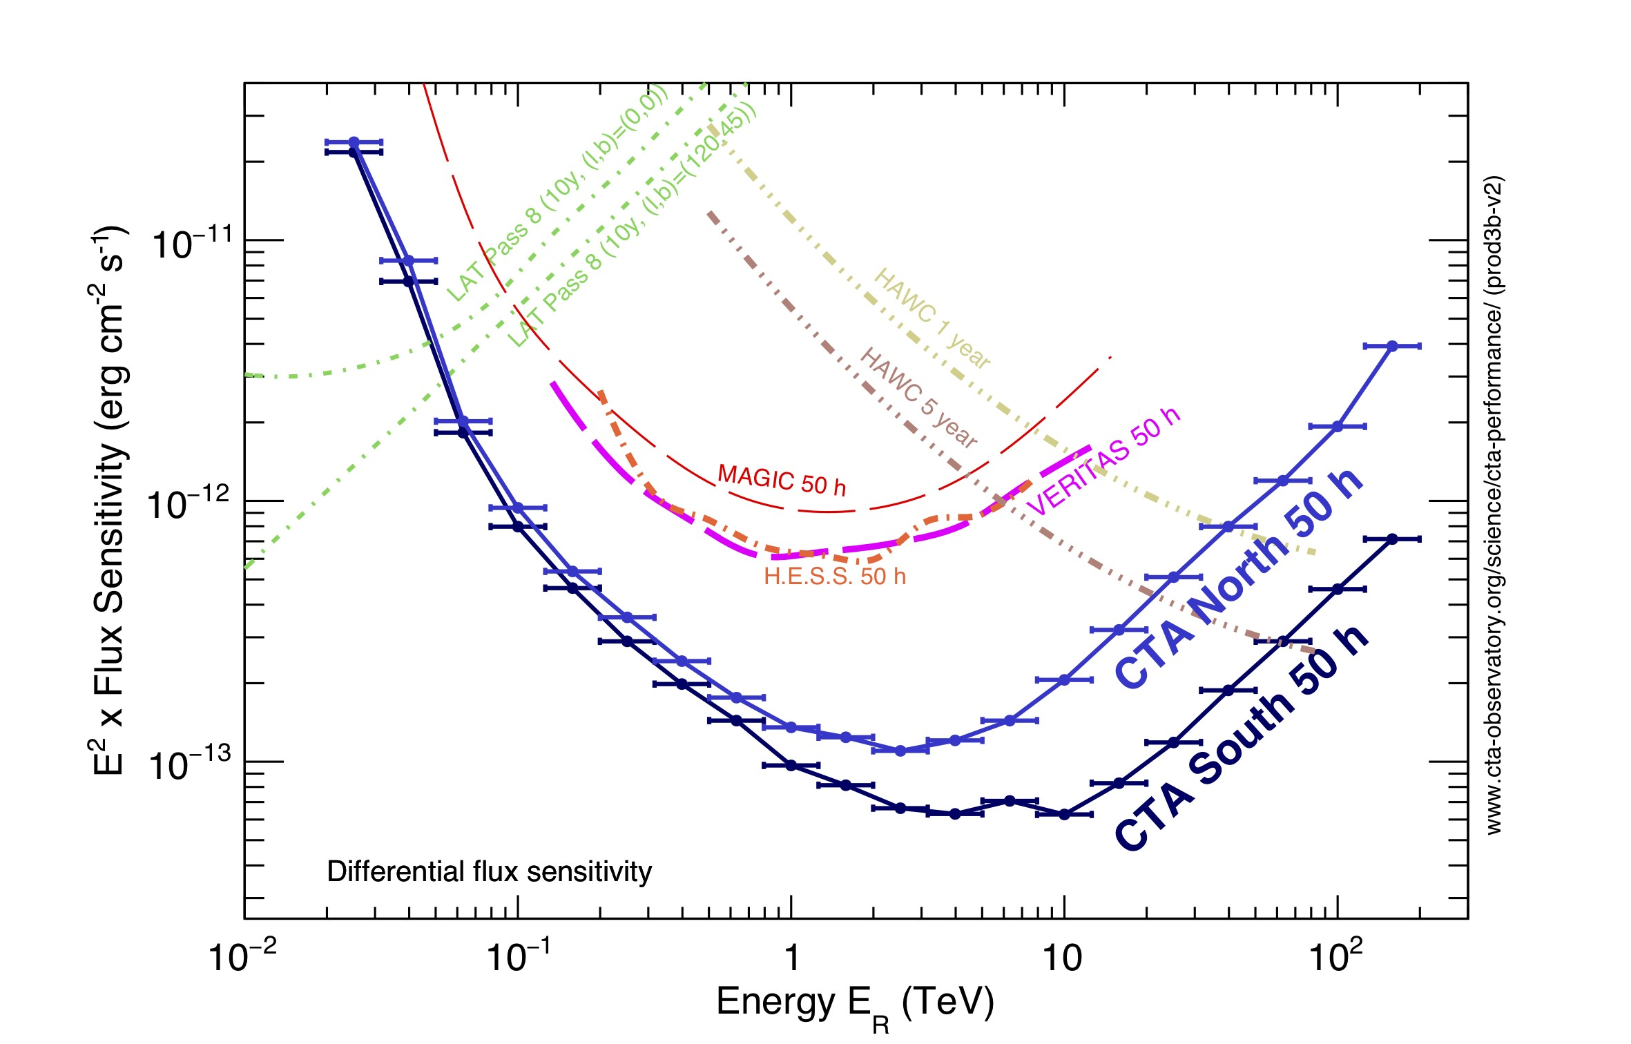

Figure 2.12: Differential sensitivity of CTA for 50 h observation compared to other *γ*-ray experiments, from [43].

1. In: ().
2. A. A. Abdo et al. “A population of gamma-ray emitting globular clusters seen with the Fermi Large Area Telescope”. In: *Astronomy and Astrophysics* 524,

A75 (2010), A75. doi: [10.1051/0004-6361/201014458.](http://dx.doi.org/10.1051/0004-6361/201014458) arXiv: [1003.3588 [astro-ph.GA].](http://arxiv.org/abs/1003.3588)

1. A. A. Abdo et al. “Detection of Gamma-Ray Emission from the Starburst Galaxies M82 and NGC 253 with the Large Area Telescope on Fermi”. In: *Astrophysical Journal* 709.2 (2010), pp. L152–L157. doi: [10.1088/20418205/709/2/L152.](http://dx.doi.org/10.1088/2041-8205/709/2/L152) arXiv: [0911.5327[astro-ph.HE].](http://arxiv.org/abs/0911.5327)
2. A. A. Abdo et al. “Detection of the Small Magellanic Cloud in gamma-rays with Fermi/LAT”. In: *Astronomy and Astrophysics* 523, A46 (2010), A46. doi:

[10.1051/0004-6361/201014855.](http://dx.doi.org/10.1051/0004-6361/201014855) arXiv: [1008.2127[astro-ph.HE].](http://arxiv.org/abs/1008.2127)

1. A. A. Abdo et al. “Fermi Large Area Telescope Observations of the Crab Pulsar And Nebula”. In: 708.2 (2010), pp. 1254–1267. doi: [10.1088/0004637X/708/2/1254.](http://dx.doi.org/10.1088/0004-637X/708/2/1254) arXiv: [0911.2412[astro-ph.HE].](http://arxiv.org/abs/0911.2412)



Bibliography

1. A. A. Abdo et al. “Gamma-Ray Emission Concurrent with the Nova in the Symbiotic Binary V407 Cygni”. In: *Science* 329.5993 (2010), pp. 817–821. doi:

[10.1126/science.1192537.](http://dx.doi.org/10.1126/science.1192537) arXiv: [1008.3912[astro-ph.HE].](http://arxiv.org/abs/1008.3912)

1. A. A. Abdo et al. “Observations of Milky Way Dwarf Spheroidal Galaxies with the Fermi-Large Area Telescope Detector and Constraints on Dark Matter Models”. In: *Astrophysical Journal* 712.1 (2010), pp. 147–158. doi: [10.1088/ 0004-637X/712/1/147.](http://dx.doi.org/10.1088/0004-637X/712/1/147) arXiv: [1001.4531[astro-ph.CO].](http://arxiv.org/abs/1001.4531)

57

1. A. A. Abdo et al. “Observations of the Large Magellanic Cloud with Fermi”. In: *Astronomy and Astrophysics* 512, A7 (2010), A7. doi: [10.1051/00046361/200913474.](http://dx.doi.org/10.1051/0004-6361/200913474) arXiv: [1001.3298[astro-ph.HE].](http://arxiv.org/abs/1001.3298)
2. A. Abramowski et al. “Search for a Dark Matter Annihilation Signal from the Galactic Center Halo with H.E.S.S.” In: *Physical Review Letters* 106.16, 161301 (2011), p. 161301. doi: [10.1103/PhysRevLett.106.161301.](http://dx.doi.org/10.1103/PhysRevLett.106.161301) arXiv: [1103.3266[astro-ph.HE].](http://arxiv.org/abs/1103.3266)
3. A. Abramowski et al. “Search for Dark Matter Annihilation Signals from the Fornax Galaxy Cluster with H.E.S.S.” In: *Astrophysical Journal* 750.2, 123

(2012), p. 123. doi: [10.1088/0004-637X/750/2/123.](http://dx.doi.org/10.1088/0004-637X/750/2/123) arXiv: [1202.5494 [astro-ph.HE].](http://arxiv.org/abs/1202.5494)

1. A. Abramowski et al. “Search for dark matter annihilation signatures in H.E.S.S.

observations of dwarf spheroidal galaxies”. In: *Physical Review D* 90.11, 112012

(2014), p. 112012. doi: [10.1103/PhysRevD.90.112012.](http://dx.doi.org/10.1103/PhysRevD.90.112012) arXiv: [1410.2589 [astro-ph.HE].](http://arxiv.org/abs/1410.2589)

1. V. A. Acciari et al. “Constraining dark matter lifetime with a deep gamma-ray survey of the Perseus galaxy cluster with MAGIC”. In: *Physics of the Dark Universe* 22 (2018), pp. 38–47. doi: [10.1016/j.dark.2018.08.002.](http://dx.doi.org/10.1016/j.dark.2018.08.002) arXiv:

[1806.11063[astro-ph.HE].](http://arxiv.org/abs/1806.11063)

1. F. Acero et al. “Detection of Gamma Rays from a Starburst Galaxy”. In: *Science* 326.5956 (2009), p. 1080. doi: [10.1126/science.1178826.](http://dx.doi.org/10.1126/science.1178826) arXiv: [0909.4651[astro-ph.HE].](http://arxiv.org/abs/0909.4651)
2. M. Ackermann et al. “Constraints on dark matter annihilation in clusters of galaxies with the Fermi large area telescope”. In: *Journal of Cosmology*

*and Astroparticle Physics* 2010.5, 025 (2010), p. 025. doi: [10.1088/14757516/2010/05/025.](http://dx.doi.org/10.1088/1475-7516/2010/05/025) arXiv: [1002.2239[astro-ph.CO].](http://arxiv.org/abs/1002.2239)

1. M. Ackermann et al. “Deep view of the Large Magellanic Cloud with six years of Fermi-LAT observations”. In: *Astronomy and Astrophysics* 586, A71 (2016), A71. doi: [10.1051/0004-6361/201526920.](http://dx.doi.org/10.1051/0004-6361/201526920) arXiv: [1509.06903[astro-ph.HE].](http://arxiv.org/abs/1509.06903)
2. M. Ackermann et al. “Detection of the Characteristic Pion-Decay Signature in Supernova Remnants”. In: *Science* 339.6121 (2013), pp. 807–811. doi: [10.](http://dx.doi.org/10.1126/science.1231160)

[1126/science.1231160.](http://dx.doi.org/10.1126/science.1231160) arXiv: [1302.3307[astro-ph.HE].](http://arxiv.org/abs/1302.3307)

1. M. Ackermann et al. “Fermi establishes classical novae as a distinct class of gamma-ray sources”. In: *Science* 345.6196 (2014), pp. 554–558. doi: [10.1126/ science.1253947.](http://dx.doi.org/10.1126/science.1253947) arXiv: [1408.0735[astro-ph.HE].](http://arxiv.org/abs/1408.0735)
2. M. Ackermann et al. “Fermi-LAT Observations of the Gamma-Ray Burst GRB 130427A”. In: *Science* 343.6166 (2014), pp. 42–47. doi: [10.1126/science.](http://dx.doi.org/10.1126/science.1242353)

[1242353.](http://dx.doi.org/10.1126/science.1242353) arXiv: [1311.5623[astro-ph.HE].](http://arxiv.org/abs/1311.5623)

1. M. Ackermann et al. “GeV Gamma-ray Flux Upper Limits from Clusters of Galaxies”. In: *Astrophysical Journal* 717.1 (2010), pp. L71–L78. doi: [10.1088/ 2041-8205/717/1/L71.](http://dx.doi.org/10.1088/2041-8205/717/1/L71) arXiv: [1006.0748[astro-ph.HE].](http://arxiv.org/abs/1006.0748)
2. M. Ackermann et al. “Observations of M31 and M33 with the Fermi Large Area Telescope: A Galactic Center Excess in Andromeda?” In: *Astrophysical Journal* 836.2, 208 (2017), p. 208. doi: [10.3847/1538-4357/aa5c3d.](http://dx.doi.org/10.3847/1538-4357/aa5c3d) arXiv: [1702.08602[astro-ph.HE].](http://arxiv.org/abs/1702.08602)
3. M. Ackermann et al. “The Fermi Galactic Center GeV Excess and Implications for Dark Matter”. In: *Astrophysical Journal* 840.1, 43 (2017), p. 43. doi:

[10.3847/1538-4357/aa6cab.](http://dx.doi.org/10.3847/1538-4357/aa6cab) arXiv: [1704.03910[astro-ph.HE].](http://arxiv.org/abs/1704.03910)

1. M. Ackermann et al. “The Spectrum and Morphology of the Fermi Bubbles”. In: *Astrophysical Journal* 793.1, 64 (2014), p. 64. doi: [10.1088/0004-637X/ 793/1/64.](http://dx.doi.org/10.1088/0004-637X/793/1/64) arXiv: [1407.7905[astro-ph.HE].](http://arxiv.org/abs/1407.7905)
2. F. Aharonian et al. “HESS Observations of the Galactic Center Region and

Their Possible Dark Matter Interpretation”. In: *Physical Review Letters* 97.22, 221102 (2006), p. 221102. doi: [10.1103/PhysRevLett.97.221102.](http://dx.doi.org/10.1103/PhysRevLett.97.221102) arXiv: [astro-ph/0610509[astro-ph].](http://arxiv.org/abs/astro-ph/0610509)

1. Felix A. Aharonian. *Very high energy cosmic gamma radiation : a crucial window on the extreme Universe*. 2004. doi: [10.1142/4657.](http://dx.doi.org/10.1142/4657)
2. M. L. Ahnen et al. “Indirect dark matter searches in the dwarf satellite galaxy Ursa Major II with the MAGIC telescopes”. In: *Journal of Cosmology*

*and Astroparticle Physics* 2018.3, 009 (2018), p. 009. doi: [10.1088/14757516/2018/03/009.](http://dx.doi.org/10.1088/1475-7516/2018/03/009) arXiv: [1712.03095[astro-ph.HE].](http://arxiv.org/abs/1712.03095)

1. M. Ajello et al. “Fermi-LAT Observations of LIGO/Virgo Event GW170817”. In: 861.2, 85 (2018), p. 85. doi: [10.3847/1538-4357/aac515.](http://dx.doi.org/10.3847/1538-4357/aac515)
2. J. Albert et al. “Observation of Gamma Rays from the Galactic Center with the MAGIC Telescope”. In: 638.2 (2006), pp. L101–L104. doi: [10.1086/501164.](http://dx.doi.org/10.1086/501164) arXiv: [astro-ph/0512469[astro-ph].](http://arxiv.org/abs/astro-ph/0512469)
3. J. Aleksić et al. “Constraining cosmic rays and magnetic fields in the Perseus galaxy cluster with TeV observations by the MAGIC telescopes”. In: *Astronomy*

*and Astrophysics* 541, A99 (2012), A99. doi: [10.1051/0004-6361/201118502.](http://dx.doi.org/10.1051/0004-6361/201118502) arXiv: [1111.5544[astro-ph.HE].](http://arxiv.org/abs/1111.5544)

1. E. Aliu et al. “Observation of Pulsed *γ*-Rays Above 25 GeV from the Crab Pulsar with MAGIC”. In: *Science* 322.5905 (2008), p. 1221. doi: [10.1126/ science.1164718.](http://dx.doi.org/10.1126/science.1164718) arXiv: [0809.2998[astro-ph].](http://arxiv.org/abs/0809.2998)
2. Heinz Andernach and Fritz Zwicky. “English and Spanish Translation of Zwicky’s (1933) The Redshift of Extragalactic Nebulae”. In: *arXiv e-prints*, arXiv:1711.01693 (2017), arXiv:1711.01693. arXiv: [1711.01693[astro-ph.IM].](http://arxiv.org/abs/1711.01693)
3. S. Archambault et al. “Dark matter constraints from a joint analysis of dwarf

Spheroidal galaxy observations with VERITAS”. In: *Physical Review D* 95.8, 082001 (2017), p. 082001. doi: [10.1103/PhysRevD.95.082001.](http://dx.doi.org/10.1103/PhysRevD.95.082001) arXiv: [1703.](http://arxiv.org/abs/1703.04937)

[04937[astro-ph.HE].](http://arxiv.org/abs/1703.04937)

1. A. Archer et al. “TeV Gamma-Ray Observations of the Galactic Center Ridge by VERITAS”. In: 821.2, 129 (2016), p. 129. doi: [10.3847/0004-637X/821/2/129.](http://dx.doi.org/10.3847/0004-637X/821/2/129) arXiv: [1602.08522[astro-ph.HE].](http://arxiv.org/abs/1602.08522)
2. W. B. Atwood et al. “The Large Area Telescope on the Fermi Gamma-Ray Space Telescope Mission”. In: 697.2 (2009), pp. 1071–1102. doi: [10.1088/0004637X/697/2/1071.](http://dx.doi.org/10.1088/0004-637X/697/2/1071) arXiv: [0902.1089[astro-ph.IM].](http://arxiv.org/abs/0902.1089)
3. G A Bazilevskaya. “Once again about origin of the solar cosmic rays”. In: *Journal of Physics: Conference Series* 798 (2017), p. 012034. doi: [10.1088/ 1742-6596/798/1/012034.](http://dx.doi.org/10.1088/1742-6596/798/1/012034) url: [https://doi.org/10.1088%2F17426596%2F798%2F1%2F012034.](https://doi.org/10.1088%2F1742-6596%2F798%2F1%2F012034)
4. Julia Becker Tjus et al. “Gamma-ray emitting supernova remnants as the origin of Galactic cosmic rays?” In: *Astroparticle Physics* 81 (2016), pp. 1–

11. doi: [10.1016/j.astropartphys.2016.03.008.](http://dx.doi.org/10.1016/j.astropartphys.2016.03.008) arXiv: [1510.07801 [astro-ph.HE].](http://arxiv.org/abs/1510.07801)

1. E. G. Berezhko. “Origin of Galactic Cosmic Rays from Supernova Remnants”. In: *Nuclear Physics B Proceedings Supplements* 256 (2014), pp. 23–35. doi:

[10.1016/j.nuclphysbps.2014.10.003.](http://dx.doi.org/10.1016/j.nuclphysbps.2014.10.003) arXiv: [1412.7800[astro-ph.HE].](http://arxiv.org/abs/1412.7800)

1. Alexandre Borione et al. “CASA-MIA: A precision” EAS detector. [Cyg X-3; Her X-1; M1; NGC 1952; PSR 0531+21]”. In: (June 1993). doi: [10.1063/1.43832.](http://dx.doi.org/10.1063/1.43832)
2. Gianfranco Brunetti. “Gamma rays from galaxy clusters”. In: *AIP Conference*

*Proceedings* 1792.1 (2017), p. 020009. doi: [10.1063/1.4968894.](http://dx.doi.org/10.1063/1.4968894) eprint: [https: //aip.scitation.org/doi/pdf/10.1063/1.4968894.](https://aip.scitation.org/doi/pdf/10.1063/1.4968894) url: [https://aip. scitation.org/doi/abs/10.1063/1.4968894.](https://aip.scitation.org/doi/abs/10.1063/1.4968894)

1. Gianfranco Brunetti and Thomas W. Jones. “Cosmic Rays in Galaxy Clusters and Their Nonthermal Emission”. In: *International Journal of Modern Physics D* 23.4, 1430007-98 (2014), pp. 1430007–98. doi: [10.1142/S0218271814300079.](http://dx.doi.org/10.1142/S0218271814300079) arXiv: [1401.7519[astro-ph.CO].](http://arxiv.org/abs/1401.7519)
2. Matthew R. Buckley et al. “Search for gamma-ray emission from dark matter annihilation in the large magellanic cloud with the fermi large area telescope”.

In: *Physical Review D* 91.10, 102001 (2015), p. 102001. doi: [10.1103/PhysRevD.](http://dx.doi.org/10.1103/PhysRevD.91.102001)

[91.102001.](http://dx.doi.org/10.1103/PhysRevD.91.102001) arXiv: [1502.01020[astro-ph.HE].](http://arxiv.org/abs/1502.01020)

1. S. Chandrasekhar. “The Maximum Mass of Ideal White Dwarfs”. In: *Astrophysical Journal* 74 (July 1931), p. 81. doi: [10.1086/143324.](http://dx.doi.org/10.1086/143324)
2. Cherenkov Telescope Array Consortium et al. *Science with the Cherenkov Telescope Array*. 2019. doi: [10.1142/10986.](http://dx.doi.org/10.1142/10986)
3. *Cherenkov Telescope Array Observatory homepage*. [https://www.cta-observat](https://www.cta-observatory.org/)ory.

[org/.](https://www.cta-observatory.org/)

1. Marco Cirelli et al. “Gamma ray constraints on decaying dark matter”. In:

*Physical Review D* 86.8, 083506 (2012), p. 083506. doi: [10.1103/PhysRevD.](http://dx.doi.org/10.1103/PhysRevD.86.083506)

[86.083506.](http://dx.doi.org/10.1103/PhysRevD.86.083506) arXiv: [1205.5283[astro-ph.CO].](http://arxiv.org/abs/1205.5283)

1. *Classical Novae*. 2nd ed. Cambridge Astrophysics. Cambridge University Press, 2008. doi: [10.1017/CBO9780511536168.](http://dx.doi.org/10.1017/CBO9780511536168)
2. Tarek Hassan Collado. “Sensivity studies for the Cherenkov Telescope Array”.

Tesis inédita de la Universidad Complutense de Madrid, Facultad de Ciencias Físicas, Departamento de Física Atómica, Molecular y Nuclear, leída el 28-092015. Madrid, 2016. url: [https://eprints.ucm.es/35143/.](https://eprints.ucm.es/35143/)

1. R. H. D. Corbet et al. “A Luminous Gamma-ray Binary in the Large Magellanic Cloud”. In: *Astrophysical Journal* 829.2, 105 (2016), p. 105. doi: [10.3847/0004637X/829/2/105.](http://dx.doi.org/10.3847/0004-637X/829/2/105) arXiv: [1608.06647[astro-ph.HE].](http://arxiv.org/abs/1608.06647)
2. Juan Cortina. “Highlights of the MAGIC telescopes”. In: *International Cosmic Ray Conference*. Vol. 11. International Cosmic Ray Conference. 2011, p. 147. doi: [10.7529/ICRC2011/V12/H12.](http://dx.doi.org/10.7529/ICRC2011/V12/H12) arXiv: [1110.4747[astro-ph.HE].](http://arxiv.org/abs/1110.4747)
3. P. Cristofari et al. “On the search for Galactic supernova remnant PeVatrons with current TeV instruments”. In: 479.3 (2018), pp. 3415–3421. doi: [10.1093/ mnras/sty1589.](http://dx.doi.org/10.1093/mnras/sty1589) arXiv: [1803.09728[astro-ph.HE].](http://arxiv.org/abs/1803.09728)
4. Bożena Czerny et al. “Astronomical Distance Determination in the Space Age. Secondary Distance Indicators”. In: *Space Science Reviews* 214.1, 32

(2018), p. 32. doi: [10.1007/s11214-018-0466-9.](http://dx.doi.org/10.1007/s11214-018-0466-9) arXiv: [1801.00598 [astro-ph.GA].](http://arxiv.org/abs/1801.00598)

1. Mathieu de Naurois. “Analysis methods for Atmospheric Cerenkov Telescopes”. In: *arXiv e-prints*, astro-ph/0607247 (2006), astro–ph/0607247. arXiv: [astroph/0607247[astro-ph].](http://arxiv.org/abs/astro-ph/0607247)
2. Mathieu de Naurois and Daniel Mazin. “Ground-based detectors in very-highenergy gamma-ray astronomy”. In: *Comptes Rendus Physique* 16.6-7 (2015), pp. 610–627. doi: [10.1016/j.crhy.2015.08.011.](http://dx.doi.org/10.1016/j.crhy.2015.08.011) arXiv: [1511.00463 [astro-ph.IM].](http://arxiv.org/abs/1511.00463)
3. Charles Dennison Dermer and Berrie Giebels. “Active galactic nuclei at gammaray energies”. In: *Comptes Rendus Physique* 17.6 (2016), pp. 594–616. doi:

[10.1016/j.crhy.2016.04.004.](http://dx.doi.org/10.1016/j.crhy.2016.04.004) arXiv: [1602.06592[astro-ph.HE].](http://arxiv.org/abs/1602.06592)

1. G. Di Sciascio and LHAASO Collaboration. “The LHAASO experiment: From Gamma-Ray Astronomy to Cosmic Rays”. In: *Nuclear and Particle Physics Proceedings* 279 (2016), pp. 166–173. doi: [10.1016/j.nuclphysbps.2016.10.](http://dx.doi.org/10.1016/j.nuclphysbps.2016.10.024)

[024.](http://dx.doi.org/10.1016/j.nuclphysbps.2016.10.024) arXiv: [1602.07600[astro-ph.HE].](http://arxiv.org/abs/1602.07600)

1. Giuseppe ARGO-YBJ Collaboration Di Sciascio. “Latest results from the ARGO-YBJ experiment”. In: *Journal of Physics Conference Series*. Vol. 632.

Journal of Physics Conference Series. 2015, p. 012089. doi: [10.1088/17426596/632/1/012089.](http://dx.doi.org/10.1088/1742-6596/632/1/012089) arXiv: [1503.09102[astro-ph.HE].](http://arxiv.org/abs/1503.09102)

1. A. Domínguez et al. “Extragalactic background light inferred from AEGIS galaxy-SED-type fractions”. In: *Monthly Notices of the RAS* 410.4 (2011), pp. 2556–2578. doi: [10.1111/j.1365-2966.2010.17631.x.](http://dx.doi.org/10.1111/j.1365-2966.2010.17631.x) arXiv: [1007.1459 [astro-ph.CO].](http://arxiv.org/abs/1007.1459)
2. Guillaume Dubus. “Gamma-ray binaries and related systems”. In: *Astronomy and Astrophysics Reviews* 21, 64 (2013), p. 64. doi: [10.1007/s00159-0130064-5.](http://dx.doi.org/10.1007/s00159-013-0064-5) arXiv: [1307.7083[astro-ph.HE].](http://arxiv.org/abs/1307.7083)
3. J. Einasto. “On the Construction of a Composite Model for the Galaxy and on the Determination of the System of Galactic Parameters”. In: *Trudy As-*

*trofizicheskogo Instituta Alma-Ata* 5 (1965), pp. 87–100.

1. Enrico Fermi. “On the Origin of the Cosmic Radiation”. In: Dec. 1972, pp. 238– 252. isbn: 9780080167244. doi: [10.1016/B978-0-08-016724-4.50024-0.](http://dx.doi.org/10.1016/B978-0-08-016724-4.50024-0)
2. Victoria Fonseca. “The HEGRA experiment (High Energy Gamma Ray Array)”. In: *Nuclear Physics B - Proceedings Supplements* 28.1 (1992), pp. 409

–412. issn: 0920-5632. doi: [https://doi.org/10.1016/0920-5632(92) 90205-7.](http://dx.doi.org/https://doi.org/10.1016/0920-5632(92)90205-7) url: [http://www.sciencedirect.com/science/article/pii/ 0920563292902057.](http://www.sciencedirect.com/science/article/pii/0920563292902057)

1. Alberto Franceschini and Giulia Rodighiero. “The extragalactic background light revisited and the cosmic photon-photon opacity”. In: *Astronomy and Astrophysics* 603, A34 (2017), A34. doi: [10.1051/0004-6361/201629684.](http://dx.doi.org/10.1051/0004-6361/201629684) arXiv: [1705.10256[astro-ph.HE].](http://arxiv.org/abs/1705.10256)
2. P. C. C. Freire et al. “Fermi Detection of a Luminous -Ray Pulsar in a Globular Cluster”. In: *Science* 334.6059 (2011), pp. 1107–1110. issn: 0036-8075. doi:

[10.1126/science.1207141.](http://dx.doi.org/10.1126/science.1207141) eprint: [https://science.sciencemag.org/ content/334/6059/1107.full.pdf.](https://science.sciencemag.org/content/334/6059/1107.full.pdf) url: [https://science.sciencemag.](https://science.sciencemag.org/content/334/6059/1107)

[org/content/334/6059/1107.](https://science.sciencemag.org/content/334/6059/1107)

1. A. Furniss. “Recent Highlights from the VERITAS Gamma-ray Observatory”. In: *American Astronomical Society Meeting Abstracts #233*. Vol. 233. American Astronomical Society Meeting Abstracts. Jan. 2019, p. 433.04.
2. Bryan M. Gaensler and Patrick O. Slane. “The Evolution and Structure of Pulsar Wind Nebulae”. In: *Annual Review of Astron and Astrophys* 44.1 (2006), pp. 17–47. doi: [10.1146/annurev.astro.44.051905.092528.](http://dx.doi.org/10.1146/annurev.astro.44.051905.092528) arXiv: [astroph/0601081[astro-ph].](http://arxiv.org/abs/astro-ph/0601081)
3. T. K. Gaisser, R. Engel, and E. Resconi. *Cosmic Rays and Particle Physics*. June 2016.
4. Michael Gajdus. “The Vela pulsar in very high energy gamma-rays with

H.E.S.S. II”. PhD thesis. Humboldt-Universität zu Berlin, MathematischNaturwissenschaftliche Fakultät, 2016. doi: [http://dx.doi.org/10.18452/ 17610.](http://dx.doi.org/http://dx.doi.org/10.18452/17610)

1. G. Ghirlanda et al. “Are short Gamma Ray Bursts similar to long ones?” In: *Journal of High Energy Astrophysics* 7 (2015). Swift 10 Years of Discovery, a novel approach to Time Domain Astronomy, pp. 81 –89. issn: 2214-4048. doi: [https://doi.org/10.1016/j.jheap.2015.04.002.](http://dx.doi.org/https://doi.org/10.1016/j.jheap.2015.04.002) url: [http:](http://www.sciencedirect.com/science/article/pii/S2214404815000129)

[//www.sciencedirect.com/science/article/pii/S2214404815000129.](http://www.sciencedirect.com/science/article/pii/S2214404815000129)

1. A. Goldstein et al. “An Ordinary Short Gamma-Ray Burst with Extraordinary Implications: Fermi-GBM Detection of GRB 170817A”. In: *The Astrophysical Journal* 848.2 (2017), p. L14. doi: [10.3847/2041-8213/aa8f41.](http://dx.doi.org/10.3847/2041-8213/aa8f41)url: [https: //doi.org/10.3847%2F2041-8213%2Faa8f41.](https://doi.org/10.3847%2F2041-8213%2Faa8f41)
2. A. Goldwurm. “An Overview of the High-Energy Emission from the Galactic Center”. In: *The Galactic Center: a Window to the Nuclear Environment of*

*Disk Galaxies*. Ed. by M. R. Morris, Q. D. Wang, and F. Yuan. Vol. 439. Astronomical Society of the Pacific Conference Series. 2011, p. 391. arXiv: [1007.4174[astro-ph.HE].](http://arxiv.org/abs/1007.4174)

1. Andrea Goldwurm. “High energy activity of the super-massive black hole at the Galactic Center”. In: *Comptes Rendus Physique* 8 (2007), pp. 35–44. doi:

[10.1016/j.crhy.2006.11.001.](http://dx.doi.org/10.1016/j.crhy.2006.11.001) arXiv: [0705.4091[astro-ph].](http://arxiv.org/abs/0705.4091)

1. S R Gozzini et al. “The supernova remnant W51C: a plausible source of galactic cosmic rays?” In: *Journal of Physics: Conference Series* 409 (2013), p. 012116. doi: [10.1088/1742-6596/409/1/012116.](http://dx.doi.org/10.1088/1742-6596/409/1/012116) url: [https://doi.org/10.1088% 2F1742-6596%2F409%2F1%2F012116.](https://doi.org/10.1088%2F1742-6596%2F409%2F1%2F012116)
2. H. E. S. S. Collaboration et al. “HESS J1818-154, a new composite supernova remnant discovered in TeV gamma rays and X-rays”. In: 562, A40 (2014), A40.

doi: [10.1051/0004-6361/201322914.](http://dx.doi.org/10.1051/0004-6361/201322914) arXiv: [1310.6956[astro-ph.HE].](http://arxiv.org/abs/1310.6956)

1. H. E. S. S. Collaboration et al. “Search for very-high-energy *γ*-ray emission from

Galactic globular clusters with H.E.S.S.” In: *Astronomy and Astrophysics* 551,

A26 (2013), A26. doi: [10.1051/0004-6361/201220719.](http://dx.doi.org/10.1051/0004-6361/201220719) arXiv: [1301.1678 [astro-ph.HE].](http://arxiv.org/abs/1301.1678)

1. H. E. S. S. Collaboration et al. “The exceptionally powerful TeV *γ*-ray emitters in the Large Magellanic Cloud”. In: *Science* 347.6220 (2015), pp. 406–412. doi: [10.1126/science.1261313.](http://dx.doi.org/10.1126/science.1261313) arXiv: [1501.06578[astro-ph.HE].](http://arxiv.org/abs/1501.06578)
2. H. E. S. S. Collaboration et al. “The H.E.S.S. Galactic plane survey”. In: 612, A1 (2018), A1. arXiv: [1804.02432[astro-ph.HE].](http://arxiv.org/abs/1804.02432)
3. W. F. Hanlon. *Updated cosmic ray spectrum*. 2015. url: [http://www.physics.](http://www.physics.utah.edu/~whanlon/spectrum.html)

[utah.edu/~whanlon/spectrum.html.](http://www.physics.utah.edu/~whanlon/spectrum.html)

1. Martin Harwit. *Astrophysical Concepts. Fourth edition*. Springer Science Business Media, 2006. url: [https://www.springer.com/gp/book/9781475720198.](https://www.springer.com/gp/book/9781475720198)
2. W. Heitler. *Quantum theory of radiation*. 1954.
3. L. Hernquist. “An analytical model for spherical galaxies and bulges”. In: *Astrophysical Journal* 356 (June 1990), pp. 359–364. doi: [10.1086/168845.](http://dx.doi.org/10.1086/168845)
4. John W. Hewitt and Marianne Lemoine-Goumard. “Observations of supernova remnants and pulsar wind nebulae at gamma-ray energies”. In: *Comptes Rendus Physique* 16.6-7 (2015), pp. 674–685. doi: [10.1016/j.crhy.2015.08.015.](http://dx.doi.org/10.1016/j.crhy.2015.08.015) arXiv: [1510.01213[astro-ph.HE].](http://arxiv.org/abs/1510.01213)
5. A. M. Hillas. “Cerenkov light images of EAS produced by primary gamma”. In: *19th International Cosmic Ray Conference (ICRC19), Volume 3*. Ed. by F. C. Jones. Vol. 3. International Cosmic Ray Conference. Aug. 1985.
6. A. M. Hillas. “The Origin of Ultrahigh-Energy Cosmic Rays”. In: *Ann. Rev.*

*Astron. Astrophys.* 22 (1984), pp. 425–444. doi: [10.1146/annurev.aa.22.](http://dx.doi.org/10.1146/annurev.aa.22.090184.002233)

[090184.002233.](http://dx.doi.org/10.1146/annurev.aa.22.090184.002233)

1. Kouichi Hirotani. “High Energy Emission from Rotation-Powered Pulsars: Outer-gap vs. Slot-gap Models”. In: *arXiv e-prints*, arXiv:0809.1283 (2008), arXiv:0809.1283. arXiv: [0809.1283[astro-ph].](http://arxiv.org/abs/0809.1283)
2. Xiaoyuan Huang, Gilles Vertongen, and Christoph Weniger. “Probing dark matter decay and annihilation with Fermi LAT observations of nearby galaxy clusters”. In: *Journal of Cosmology and Astroparticle Physics* 2012.1, 042 (2012), p. 042. doi: [10.1088/1475-7516/2012/01/042.](http://dx.doi.org/10.1088/1475-7516/2012/01/042) arXiv: [1110.1529 [hep-ph].](http://arxiv.org/abs/1110.1529)
3. X. A. Huo et al. “Tibet-AS *γ* Experiment”. In: *International Cosmic Ray Conference*. Vol. 2. International Cosmic Ray Conference. 1990, p. 427.
4. J.V. Jelley. *Čerenkov radiation, and its applications*. Pergamon Press, 1958. url: [https://books.google.es/books?id=uzZRAAAAMAAJ.](https://books.google.es/books?id=uzZRAAAAMAAJ)
5. J. Kildea et al. “The Whipple Observatory 10 m gamma-ray telescope, 19972006”. English (US). In: *Astroparticle Physics* 28.2 (Oct. 2007), pp. 182–195. issn: 0927-6505. doi: [10.1016/j.astropartphys.2007.05.004.](http://dx.doi.org/10.1016/j.astropartphys.2007.05.004)
6. Nu. Komin et al. “H.E.S.S. observations of the Large Magellanic Cloud”. In:

*arXiv e-prints*, arXiv:1201.0639 (2012), arXiv:1201.0639. arXiv: [1201.0639 [astro-ph.HE].](http://arxiv.org/abs/1201.0639)

1. C. Kouveliotou et al. “Identification of two classes of gamma-ray bursts”. In:

*Astrophysical Journal* 413 (Aug. 1993), pp. L101–L104. doi: [10.1086/186969.](http://dx.doi.org/10.1086/186969)

1. A. V. Kravtsov et al. “The Cores of Dark Matter-dominated Galaxies: Theory versus Observations”. In: *Astrophysical Journal* 502 (July 1998), pp. 48–58. doi: [10.1086/305884.](http://dx.doi.org/10.1086/305884) eprint: astro-ph/9708176.
2. M Kuhlen et al. “The Via Lactea INCITE simulation: galactic dark matter substructure at high resolution”. In: *Journal of Physics: Conference Series* 125 (2008), p. 012008. doi: [10.1088/1742-6596/125/1/012008.](http://dx.doi.org/10.1088/1742-6596/125/1/012008)
3. L. Kuiper et al. “The Crab pulsar in the 0.75-30 MeV range as seen by CGRO COMPTEL. A coherent high-energy picture from soft X-rays up to high-energy gamma-rays”. In: *Astronomy and Astrophysics* 378 (Nov. 2001), pp. 918–935. doi: [10.1051/0004-6361:20011256.](http://dx.doi.org/10.1051/0004-6361:20011256) eprint: astro-ph/0109200.
4. P. O. Lagage and C. J. Cesarsky. “The maximum energy of cosmic rays accelerated by supernova shocks.” In: 125 (1983), pp. 249–257.
5. Mariangela Lisanti. “Lectures on Dark Matter Physics”. In: *New Frontiers in Fields and Strings (TASI 2015*. 2017, pp. 399–446. doi: [10.1142/9789813149441](http://dx.doi.org/10.1142/9789813149441_0007)_ [0007.](http://dx.doi.org/10.1142/9789813149441_0007) arXiv: [1603.03797[hep-ph].](http://arxiv.org/abs/1603.03797)
6. M. S. Longair. *High Energy Astrophysics*. 3rd ed. Cambridge University Press, 2011.
7. Grzegorz (Greg) Madejski and Marek Sikora. “Gamma-Ray Observations of Active Galactic Nuclei”. In: 54 (2016), pp. 725–760. doi: [10.1146/annurevastro-081913-040044.](http://dx.doi.org/10.1146/annurev-astro-081913-040044)
8. *MAGIC homepage*. [https://magic.mpp.mpg.de/.](https://magic.mpp.mpg.de/)
9. Dan Maoz. *Astrophysics in a nutshell*. Princeton, NJ: Princeton Univ. Press, 2007. url: [https://cds.cern.ch/record/1142636.](https://cds.cern.ch/record/1142636)
10. A. McCann. “Observations of the Crab Pulsar with VERITAS”. In: *arXiv eprints*, arXiv:1303.0275 (2013), arXiv:1303.0275. arXiv: [1303.0275[astro-ph.HE].](http://arxiv.org/abs/1303.0275)
11. D. B. Melrose. “Acceleration Mechanisms”. In: *arXiv e-prints*, arXiv:0902.1803 (2009), arXiv:0902.1803. arXiv: [0902.1803[astro-ph.SR].](http://arxiv.org/abs/0902.1803)
12. R. Mirzoyan. “First time detection of a GRB at sub-TeV energies; MAGIC detects the GRB 190114C”. In: *The Astronomer’s Telegram* 12390 (Jan. 2019).
13. A. Moralejo et al. “Measurement of the EBL through a combined likelihood analysis of gamma-ray observations of blazars with the MAGIC telescopes”. In:

*35th International Cosmic Ray Conference (ICRC2017)*. Vol. 301. International Cosmic Ray Conference. 2017, p. 604. arXiv: [1709.02238[astro-ph.HE].](http://arxiv.org/abs/1709.02238)

1. Miguel A. Mostafá. “The High-Altitude Water Cherenkov Observatory”. In: *Brazilian Journal of Physics* 44.5 (2014), pp. 571–580. doi: [10.1007/s13538014-0225-7.](http://dx.doi.org/10.1007/s13538-014-0225-7) arXiv: [1310.7237[astro-ph.HE].](http://arxiv.org/abs/1310.7237)
2. J. F. Navarro, C. S. Frenk, and S. D. M. White. “The Structure of Cold Dark Matter Halos”. In: *Astrophysical Journal* 462 (May 1996), p. 563. doi:

[10.1086/177173.](http://dx.doi.org/10.1086/177173) eprint: astro-ph/9508025.

1. Julio F. Navarro. “The Structure of Cold Dark Matter Halos”. In: *Symposium - International Astronomical Union* 171 (1996), 255–258. doi: [10.1017/ S0074180900232452.](http://dx.doi.org/10.1017/S0074180900232452)
2. Stefan Ohm. “Starburst galaxies as seen by gamma-ray telescopes”. In: *Comptes Rendus Physique* 17.6 (2016), pp. 585–593. doi: [10.1016/j.crhy.2016.04. 003.](http://dx.doi.org/10.1016/j.crhy.2016.04.003) arXiv: [1601.06386[astro-ph.HE].](http://arxiv.org/abs/1601.06386)
3. Keith A. Olive. “TASI Lectures on Dark Matter”. In: *arXiv e-prints*, astroph/0301505 (2003), astro–ph/0301505. arXiv: [astro-ph/0301505[astro-ph].](http://arxiv.org/abs/astro-ph/0301505)
4. D. E. Osterbrock and G. J. Ferland. *Astrophysics of gaseous nebulae and active galactic nuclei*. 2006.
5. Igor Oya Vallejo. “Observations of Active Galactic Nuclei with the MAGIC Telescope”. PhD thesis. UCM, Madrid, Dept. Phys., 2010. url: [https:// magicold.mpp.mpg.de/publications/theses/IOya.pdf.](https://magicold.mpp.mpg.de/publications/theses/IOya.pdf)
6. D. H. Perkins. *Particle Astrophysics*. 2nd ed. Oxford University Press, 2009.
7. V. Petrosian and A. M. Bykov. “Particle Acceleration Mechanisms”. In: 134.1-4 (2008), pp. 207–227. doi: [10.1007/s11214-008-9315-6.](http://dx.doi.org/10.1007/s11214-008-9315-6) arXiv: [0801.0923 [astro-ph].](http://arxiv.org/abs/0801.0923)
8. T. Piran. “Gamma-ray bursts and the fireball model”. In: *Physics Reports* 314.6 (1999), pp. 575–667. doi: [10.1016/S0370-1573(98)00127-6.](http://dx.doi.org/10.1016/S0370-1573(98)00127-6) arXiv: [astro-ph/9810256[astro-ph].](http://arxiv.org/abs/astro-ph/9810256)
9. Tsvi Piran. “The physics of gamma-ray bursts”. In: *Reviews of Modern Physics* 76.4 (2004), pp. 1143–1210. doi: [10.1103/RevModPhys.76.1143.](http://dx.doi.org/10.1103/RevModPhys.76.1143) arXiv: [astro-ph/0405503[astro-ph].](http://arxiv.org/abs/astro-ph/0405503)
10. Planck Collaboration et al. “Planck 2013 results. XVI. Cosmological parameters”. In: *Astronomy and Astrophysics* 571, A16 (2014), A16. doi: [10.1051/ 0004-6361/201321591.](http://dx.doi.org/10.1051/0004-6361/201321591) arXiv: [1303.5076[astro-ph.CO].](http://arxiv.org/abs/1303.5076)
11. A I Podgorny et al. “The spectrum of solar relativistic cosmic ray measurements and numerical simulation”. In: *Journal of Physics: Conference Series* 798 (2017), p. 012027. doi: [10.1088/1742-6596/798/1/012027.](http://dx.doi.org/10.1088/1742-6596/798/1/012027)url: [https: //doi.org/10.1088%2F1742-6596%2F798%2F1%2F012027.](https://doi.org/10.1088%2F1742-6596%2F798%2F1%2F012027)
12. Gerd Pühlhofer. “H.E.S.S. highlights”. In: *arXiv e-prints*, arXiv:1801.06074 (2018), arXiv:1801.06074. arXiv: [1801.06074[astro-ph.HE].](http://arxiv.org/abs/1801.06074)
13. P. V. Ramana Murthy and A. W. Wolfendale. *Gamma-ray Astronomy*. Apr. 1993, p. 273.
14. Sara Rezaeikh et al. “The star formation history of the Magellanic Clouds derived from long-period variable star counts”. In: *Monthly Notices of the RAS* 445.3 (2014), pp. 2214–2222. doi: [10.1093/mnras/stu1807.](http://dx.doi.org/10.1093/mnras/stu1807) arXiv: [1409.0790 [astro-ph.GA].](http://arxiv.org/abs/1409.0790)
15. Thomas P. Robitaille and Barbara A. Whitney. “The Present-Day Star Formation Rate of the Milky Way Determined from Spitzer-Detected Young Stellar Objects”. In: *Astrophysical Journal* 710.1 (2010), pp. L11–L15. doi:

[10.1088/2041-8205/710/1/L11.](http://dx.doi.org/10.1088/2041-8205/710/1/L11) arXiv: [1001.3672[astro-ph.GA].](http://arxiv.org/abs/1001.3672)

1. Bruno Rossi and Kenneth Greisen. “Cosmic-Ray Theory”. In: *Rev. Mod. Phys.*

13 (4 1941), pp. 240–309. doi: [10.1103/RevModPhys.13.240.](http://dx.doi.org/10.1103/RevModPhys.13.240) url: [https:](https://link.aps.org/doi/10.1103/RevModPhys.13.240)

[//link.aps.org/doi/10.1103/RevModPhys.13.240.](https://link.aps.org/doi/10.1103/RevModPhys.13.240)

1. V. C. Rubin, W. K. Ford Jr., and N. Thonnard. “Extended rotation curves of high-luminosity spiral galaxies. IV - Systematic dynamical properties, SA through SC”. In: *Astrophysical Journal* 225 (Nov. 1978), pp. L107–L111. doi: [10.1086/182804.](http://dx.doi.org/10.1086/182804)
2. M. A. Ruderman and P. G. Sutherland. “Theory of pulsars - Polar caps, sparks, and coherent microwave radiation”. In: *Astrophysical Journal* 196 (Feb. 1975), pp. 51–72. doi: [10.1086/153393.](http://dx.doi.org/10.1086/153393)
3. Joshua D. Simon and Marla Geha. “The Kinematics of the Ultra-faint Milky Way Satellites: Solving the Missing Satellite Problem”. In: *Astrophysical Journal* 670.1 (2007), pp. 313–331. doi: [10.1086/521816.](http://dx.doi.org/10.1086/521816) arXiv: [0706.0516 [astro-ph].](http://arxiv.org/abs/0706.0516)
4. Julian Sitarek and Włodek Bednarek. “GeV-TeV gamma rays and neutrinos from the Nova V407 Cygni”. In: *Physical Review D* 86.6, 063011 (2012),

p. 063011. doi: [10.1103/PhysRevD.86.063011.](http://dx.doi.org/10.1103/PhysRevD.86.063011) arXiv: [1208.6200[astro-ph.HE].](http://arxiv.org/abs/1208.6200)

1. Yoshiaki Sofue. “Dark Bulge, Exponential Disk, and Massive Halo in the Large Magellanic Cloud”. In: *Publications of the Astronomical Society of Japan* 51.4 (Aug. 1999), pp. 445–448. issn: 0004-6264. doi: [10.1093/pasj/51.4.445.](http://dx.doi.org/10.1093/pasj/51.4.445) eprint: [http://oup.prod.sis.lan/pasj/article-pdf/51/4/445/9716974/ pasj51-0445.pdf.](http://oup.prod.sis.lan/pasj/article-pdf/51/4/445/9716974/pasj51-0445.pdf) url: [https://doi.org/10.1093/pasj/51.4.445.](https://doi.org/10.1093/pasj/51.4.445)
2. P. Sreekumar et al. “Observations of the Large Magellanic Cloud in HighEnergy Gamma Rays”. In: *Astrophysical Journal* 400 (1992), p. L67. doi:

[10.1086/186651.](http://dx.doi.org/10.1086/186651)

1. F. W. Stecker. “The Production of Cosmic Gamma Rays in Interstellar and Intergalactic Cosmic-Ray Collisions. Iv: Gamma-Ray Production from Cosmic Proton-Antiproton Interactions”. In: *SAO Special Report* 261 (1967).
2. Meng Su, Tracy R. Slatyer, and Douglas P. Finkbeiner. “Giant Gamma-ray Bubbles from Fermi-LAT: Active Galactic Nucleus Activity or Bipolar Galactic Wind?” In: *Astrophysical Journal* 724.2 (2010), pp. 1044–1082. doi: [10.1088/ 0004-637X/724/2/1044.](http://dx.doi.org/10.1088/0004-637X/724/2/1044) arXiv: [1005.5480[astro-ph.HE].](http://arxiv.org/abs/1005.5480)
3. Pak-Hin T. Tam, Chung Y. Hui, and Albert K. H. Kong. “Gamma-ray Emission from Globular Clusters”. In: *Journal of Astronomy and Space Sciences* 33.1

(2016), pp. 1–11. doi: [10.5140/JASS.2016.33.1.1.](http://dx.doi.org/10.5140/JASS.2016.33.1.1) arXiv: [1207.7267 [astro-ph.HE].](http://arxiv.org/abs/1207.7267)

1. Vincent Tatischeff and Stefano Gabici. “Particle Acceleration by Supernova Shocks and Spallogenic Nucleosynthesis of Light Elements”. In: *Annual Review of Nuclear and Particle Science* 68.1 (2018), pp. 377–404. doi: [10.1146/ annurev-nucl-101917-021151.](http://dx.doi.org/10.1146/annurev-nucl-101917-021151) arXiv: [1803.01794[astro-ph.HE].](http://arxiv.org/abs/1803.01794)
2. S. Thoudam et al. “Cosmic-ray energy spectrum and composition up to the ankle: the case for a second Galactic component”. In: 595, A33 (2016), A33.

doi: [10.1051/0004-6361/201628894.](http://dx.doi.org/10.1051/0004-6361/201628894) arXiv: [1605.03111[astro-ph.HE].](http://arxiv.org/abs/1605.03111)

1. Satyendra Thoudam and Jörg R. Hörandel. “Nearby supernova remnants and the cosmic ray spectral hardening at high energies”. In: *Monthly Notices of the Royal Astronomical Society* 421.2 (Mar. 2012), pp. 1209–1214. issn: 0035-8711. doi: [10.1111/j.1365-2966.2011.20385.x.](http://dx.doi.org/10.1111/j.1365-2966.2011.20385.x) eprint: [http://oup.prod.sis. lan/mnras/article-pdf/421/2/1209/3924263/mnras0421-1209.pdf.](http://oup.prod.sis.lan/mnras/article-pdf/421/2/1209/3924263/mnras0421-1209.pdf) url: [https://doi.org/10.1111/j.1365-2966.2011.20385.x.](https://doi.org/10.1111/j.1365-2966.2011.20385.x)
2. C. Megan Urry and Paolo Padovani. “Unified Schemes for Radio-Loud Active

Galactic Nuclei”. In: *Publications of the Astronomical Society of the Pacific* 107

(1995), p. 803. doi: [10.1086/133630.](http://dx.doi.org/10.1086/133630) arXiv: [astro-ph/9506063[astro-ph].](http://arxiv.org/abs/astro-ph/9506063)

1. C. Megan Urry and Paolo Padovani. “Unified Schemes for Radio-Loud Active Galactic Nuclei”. In: 107 (1995), p. 803. doi: [10.1086/133630.](http://dx.doi.org/10.1086/133630) arXiv: [astroph/9506063[astro-ph].](http://arxiv.org/abs/astro-ph/9506063)
2. Igor Oya Vallejo. “Observation of active galatic [sic] nuclei with the Magic telescope”. Tesis de la Universidad Complutense de Madrid, Facultad de Ciencias Físicas, Departamento de Física Atómica, Molecular y Nuclear, leída el 23-062010. PhD thesis. Madrid, 2010. url: [https://eprints.ucm.es/11431/.](https://eprints.ucm.es/11431/)
3. Roeland P. van der Marel. “The Large Magellanic Cloud: structure and kinematics”. In: *The Local Group as an Astrophysical Laboratory*. Ed. by Mario Livio and Thomas M. Brown. Vol. 17. 2006, pp. 47–71. arXiv: [astro-ph/0404192 [astro-ph].](http://arxiv.org/abs/astro-ph/0404192)
4. VERITAS Collaboration et al. “A connection between star formation activity and cosmic rays in the starburst galaxy M82”. In: *Nature* 462.7274 (2009), pp. 770–772. doi: [10.1038/nature08557.](http://dx.doi.org/10.1038/nature08557) arXiv: [0911.0873[astro-ph.CO].](http://arxiv.org/abs/0911.0873)
5. S. P. Wakely and D. Horan. “TeVCat: An online catalog for Very High Energy Gamma-Ray Astronomy”. In: *International Cosmic Ray Conference* 3 (2008), pp. 1341–1344.
6. T.C. Weekes. *Very High Energy Gamma-Ray Astronomy*. Series in Astronomy and Astrophysics. CRC Press, 2003. isbn: 9781420033199. url: [https:// books.google.com.ua/books?id=wSTOBgAAQBAJ.](https://books.google.com.ua/books?id=wSTOBgAAQBAJ)
7. Kurt W. Weiler and Richard A. Sramek. “Supernovae and supernova remnants.” In: *Annual Review of Astron and Astrophys* 26 (1988), pp. 295–341. doi:

[10.1146/annurev.aa.26.090188.001455.](http://dx.doi.org/10.1146/annurev.aa.26.090188.001455)

1. A. S. Wilson and E. J. M. Colbert. “The Difference between Radio-loud and Radio-quiet Active Galaxies”. In: 438 (1995), p. 62. doi: [10.1086/175054.](http://dx.doi.org/10.1086/175054) arXiv: [astro-ph/9408005[astro-ph].](http://arxiv.org/abs/astro-ph/9408005)
2. J. H. K. Wu et al. “SEARCH FOR PULSED *γ*-RAY EMISSION FROM GLOBULAR CLUSTER M28”. In: *The Astrophysical Journal* 765.2 (2013), p. L47. doi: [10.1088/2041-8205/765/2/l47.](http://dx.doi.org/10.1088/2041-8205/765/2/l47)
3. Shao-Qiang Xi et al. “Detection of gamma-ray emission from the Coma cluster with Fermi Large Area Telescope and tentative evidence for an extended spatial structure”. In: *Physical Review D* 98.6, 063006 (2018), p. 063006. doi:

[10.1103/PhysRevD.98.063006.](http://dx.doi.org/10.1103/PhysRevD.98.063006) arXiv: [1709.08319[astro-ph.HE].](http://arxiv.org/abs/1709.08319)

1. H. Zhao. “Analytical models for galactic nuclei”. In: *Monthly Notices of the RAS* 278 (Jan. 1996), pp. 488–496. doi: [10.1093/mnras/278.2.488.](http://dx.doi.org/10.1093/mnras/278.2.488) eprint: astro-ph/9509122.